Dietitians: Essential Partners in Health
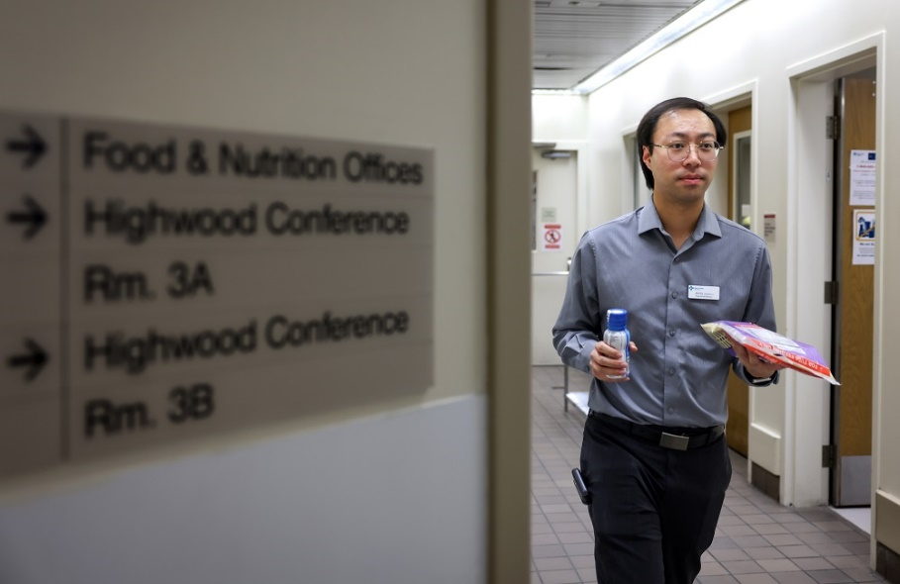
Whether at home, in the community, school, or hospital, dietitians can help at any age and stage of life. Registered dietitians are experts in diet and nutrition that can help you evaluate your diet and create a plan and detailed menu to work with your lifestyle and daily routine. Food and nutrition are a critical part of health, but food is also integral to traditions and celebrations. Dietitians work with you to support your nutritional health and find solutions that factor in taste, culture, budget, and lifestyle.

What does a dietician do?

Many people have eating habits and relationships with food which are influenced by life events, family, friends, what food is available to them, and the media. As professionals, dietitians help individuals and families navigate food allergies, intolerances and mealtime struggles which can happen for a variety of reasons. Dietitians help people of all ages reduce the risk of and treat health conditions like high blood pressure, diabetes heart disease.
A dietitian will ask you about your eating habits, suggest strategies and tips, and, most of all, make it fun by suggesting creative recipes and helping you find ways to eat foods you enjoy most. They can discuss many nutrition-related topics including:
- Healthy eating
- Pregnancy
- Breastfeeding or infant formula
- Feeding your toddler or young child
- Health conditions such as: diabetes, high cholesterol, high triglycerides, kidney disease, celiac disease, irritable bowel disease, irritable bowel syndrome, pancreatitis, cancer, obesity, malnutrition, long-COVID-19
- Eating after discharge from hospital
- Eating after surgery
- Weight gain or loss
- Digestive symptoms such as: Heartburn, constipation, diarrhea, or vomiting
- Nutrition supplements to provide extra protein and calories
- Vitamin and mineral supplements
- Food allergies

Some of the questions dietitians may ask include:
- What times of the day do you usually eat?
- Do you skip meals?
- When do you eat your largest meal of the day?
- Where do you typically eat? At work? At home?
- How do you prepare meals at home? From packaged or fresh foods?
- What are your favourite foods?

How can an AHS dietitian help?
The information below includes resources and services, developed by AHS registered dietitians, that translate the science of nutrition into practical advice and information.
AHS’ Nutrition Services develops handouts to provide patients with nutrition education and guidance. These handouts are developed by dietitians along with healthcare professionals and patients to provide up-to-date, evidence-informed information. From heart health or tips on feeding your child, you can find information on over 25 nutrition topics.
Try a workshop or a class! There are free in-person and virtual classes on a variety of topics like eating well for pregnancy, feeding babies, young children, meal planning, virtual grocery store tours, and more. Check it out to learn more about nutrition and the work of dietitians.
Are you a teacher looking for ways to promote nutrition and healthy relationships with food? Public health dietitians have developed lesson plans that align with the Alberta curriculum. There is also information available for Alberta teachers, including promoting healthy relationships with food.
Do you need to talk to someone one on one? There are HealthLink dietitians available for all Albertans. These professionals can respond to a wide variety of nutrition questions and concerns. Call 811 and ask to speak with a dietitian, or complete a self referral form.
Nutrition screening is an excellent tool to help older adults remain healthy and strong. Nutrition screening is a set of specific questions about nutrition which can determine if someone is a low, medium or high risk of developing health problems. Find out how to set up a screening program in your community for older adults or take the nutrition screen yourself!
Dietitians are essential partners in health. They hope to enrich lives with specialized food and nutrition knowledge while understanding that food plays an important role in meaning and connection throughout the lifespan.
v

Wellness Articles
Alberta Health Services encourages all Albertans to live a healthy life. These weekly Wellness Articles are created by a team of healthcare professionals from AHS in collaboration with
provincial healthcare experts in Alberta and content from myhealth.alberta.ca.
Our experts ensure this information is factual, current, and written for Albertans.
From stress-relief strategies to finding balance within your life, these Wellness Articles cover a
variety of different topics designed to inspire and educate Albertans on creating a positive and
healthy lifestyle.
We welcome and encourage weekly newspapers, community newsletters and other publications
to reproduce this information free of charge. Please credit Alberta Health Services or the identified
content provider.
If you would like to be added to the distribution list for these articles, please email: rebecca.johnson2@ahs.ca. You will receive a monthly email containing articles for the
upcoming four weeks.

