Hydration and You
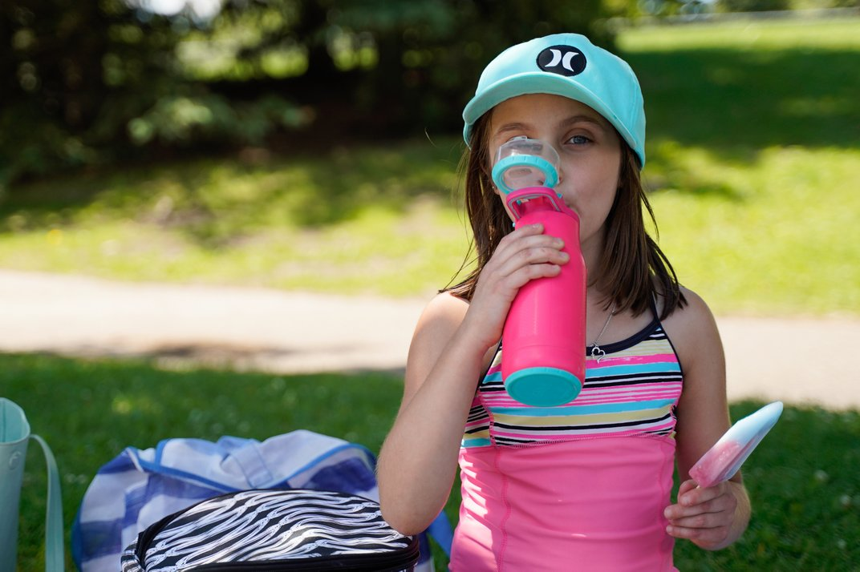
Water keeps every part of your body working properly. It helps your body flush waste and stay at the right temperature. It can help prevent kidney stones and constipation.
You lose water throughout the day, through your breath, sweat, urine, and bowel movements. If you live somewhere hot, you could lose even more fluid.
It is important to replace this lost fluid to stay healthy. If you don’t get enough water, you could become dehydrated. If you get very dehydrated, your body no longer has enough fluid to get blood to your organs which can be very dangerous.

What is the right amount of water to drink each day?
All liquids help you stay hydrated, but water is usually the best choice. A common recommendation is to drink six to eight glasses of water of day (250-mL or 8 fl oz). Some adults may need more depending on your overall health, how much you exercise, and how hot or dry the climate is.
Most people get enough fluid through the beverages they normally drink each day. You also get water through food. Some fruits and vegetables contain a lot of water, such as watermelon and lettuce.
Did you know? Experts say it is not true that beverages containing caffeine – coffee, tea, and cola drinks – are dehydrating. Healthy individuals who consume moderate amounts of caffeine do not lose more fluid than people who don’t have any caffeine. A moderate amount of caffeine is about 200- to 300-mg per day which is about two to four cups (250-ml or 8 fl oz) of coffee.
If you are feeling well, you urinate every few hours during the day, and are not feeling thirsty often, you are likely drinking enough water.
People with certain health problems, especially heart and kidney problems, need to speak with a doctor about how much water to drink.

Ways to consume more water during the day
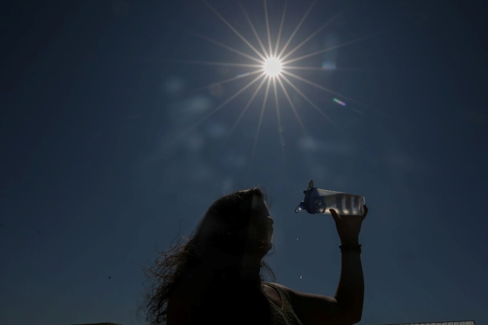
If you struggle with consuming water or remembering to drink enough throughout your day, these suggestions may help:
- Drink a glass of water when you get up in the morning, before drinking coffee or tea
- Keep a cup or water bottle by your desk at work. Take several sips of water each hour. If you don’t have a desk job, carry a container of water with you and take sips throughout the day
- Take a sip whenever you pass a drinking fountain
- Mix it up! Add sugarless flavouring to your water or a slice of lemon/lime. Alternate with sparkling water.

v

Wellness Articles
Alberta Health Services encourages all Albertans to live a healthy life. These weekly Wellness Articles are created by a team of healthcare professionals from AHS in collaboration with
provincial healthcare experts in Alberta and content from myhealth.alberta.ca.
Our experts ensure this information is factual, current, and written for Albertans.
From stress-relief strategies to finding balance within your life, these Wellness Articles cover a
variety of different topics designed to inspire and educate Albertans on creating a positive and
healthy lifestyle.
We welcome and encourage weekly newspapers, community newsletters and other publications
to reproduce this information free of charge. Please credit Alberta Health Services or the identified
content provider.
If you would like to be added to the distribution list for these articles, please email: rebecca.johnson2@ahs.ca. You will receive a monthly email containing articles for the
upcoming four weeks.

