Inpatient Referral

Department of Symptom Control and Palliative Care

- Diagnosis:
- Primary __________________________________________________________________
- Metastatic to _____________________________________________________________
- Type of service requested:
- Pain and Symptom (for patients with cancer-related symptoms that are inadequately
controlled)
- Community Liaison (for patients who require hospice placement - please complete the Hospice Referral Checklist)
- Please indicate symptom concerns, if applicable:
- Pain (location)_______________________________________________________________
- Nausea/vomiting □ Constipation □ Confusion □ Dyspnea
- Other (specify) _______________________________________________________________
- What treatments are currently being used/planned (e.g. morphine 10 mg po every 4h, radiotherapy)?

- Please: a) Fax the referral form to 432-8419 AND
b) Leave a message at:
Pain and Symptom 432-8350 or
Community Liaison 432-8887
- Does the patient need to be seen the same day (e.g. for severe symptoms)?
- Yes → Please have the referring physician page the Symptom Control/Palliative Care physician.
- No

_____________________________________ ________________________ ____________

Referring physician/Nurse Practitioner (print) Signature Date(yyyy-Mon-dd)

Symptom Control & Palliative Care
Edmonton Symptom Assessment System Numerical Scale (ESAS-r)

Please circle the number that best describes your symptoms NOW

No Pain | 0 1 2 3 4 5 6 7 8 9 10 | Worst Possible Pain
No Tiredness  (Tiredness = lack of energy) | 0 1 2 3 4 5 6 7 8 9 10 | Worst Possible Tiredness
No Drowsiness  (Drowsiness = feeling sleepy) | 0 1 2 3 4 5 6 7 8 9 10 | Worst Possible Drowsiness
No Nausea | 0 1 2 3 4 5 6 7 8 9 10 | Worst Possible Nausea
No Lack of Appetite | 0 1 2 3 4 5 6 7 8 9 10 | Worst Possible Lack of Appetite
No Shortness of Breath | 0 1 2 3 4 5 6 7 8 9 10 | Worst Possible shortness of Breath
No Depression  (Depression = feeling sad) | 0 1 2 3 4 5 6 7 8 9 10 | Worst Possible Depression
No Anxiety  (Anxiety = feeling nervous) | 0 1 2 3 4 5 6 7 8 9 10 | Worst Possible Anxiety
Best Welbeing  (Wellbeing = how you feel overall) | 0 1 2 3 4 5 6 7 8 9 10 | Worst Possible Wellbeing
No ______________________  Other problem | 0 1 2 3 4 5 6 7 8 9 10 | Worst Possible ______________

Patient Name _____________________________ Date (yyyy-Mon-dd) _________________ Time (hh:mm) ___________

Completed by □ Patient □ Family Caregiver □ Caregiver assisted
□ Health care professional caregiver

Please mark on these pictures where it is that you hurt
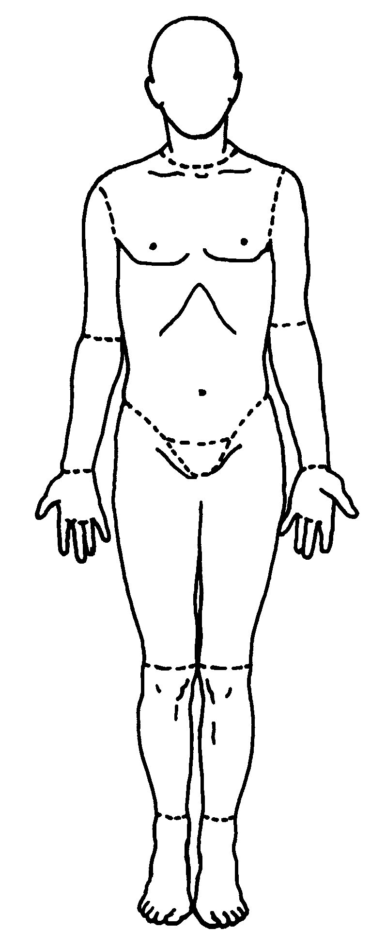
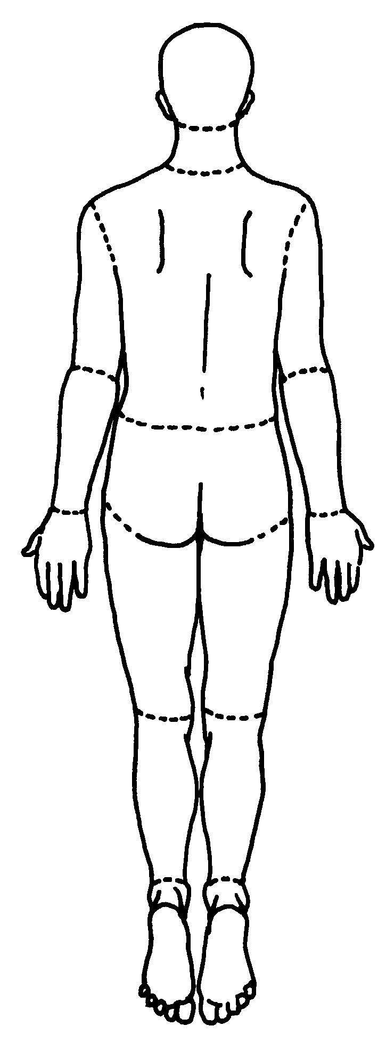
Right
Right

