Single Use Medical Device Posters
Answer Sheet

Poster | Answer: Is It Single Use?
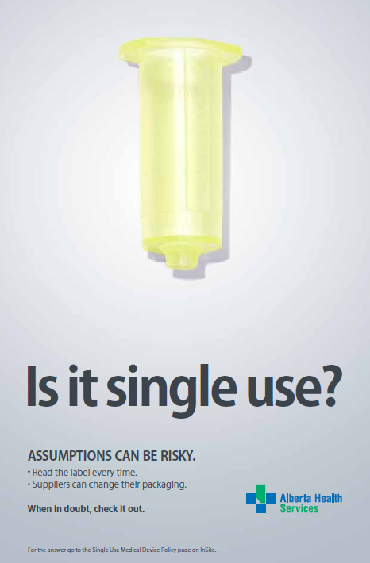 | Can be either  Vacutainer for blood letting/draws  - Vacutainer’s are available as both single-use and re-usable, therefore it is imperative you:  - Check the manufacturer’s instruction for use  - Check the packaging  - Look for the single-use symbol:
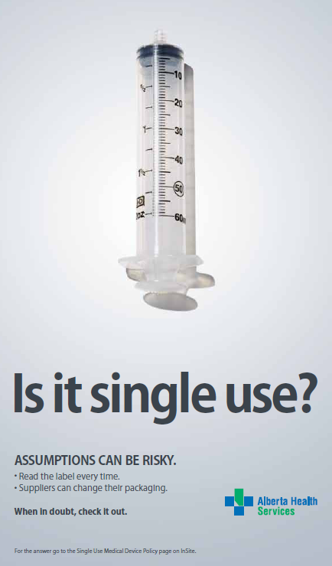 | YES  Syringe  - Syringes are not for reuse under any circumstances  - New needle, New syringe, Every time!  - Link to information: http://www.albertahealthservices.ca/hp/hp-dr-syringe-reuse.pdf

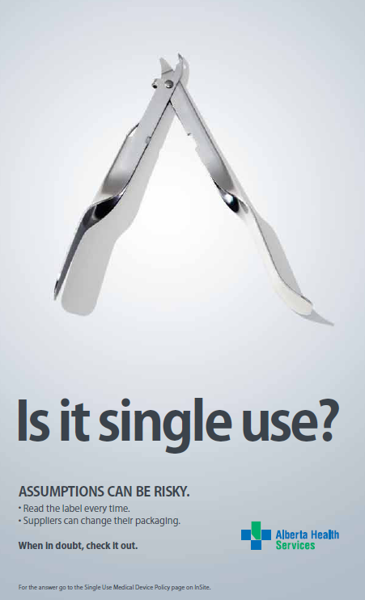 | YES  Staple Remover  - Metal does not mean a device can be reprocessed or sterilized  - Though this device is often thought to be reusable:  - Check the manufacturer’s instructions for use  - Check the packaging  - Look for the single-use symbol:
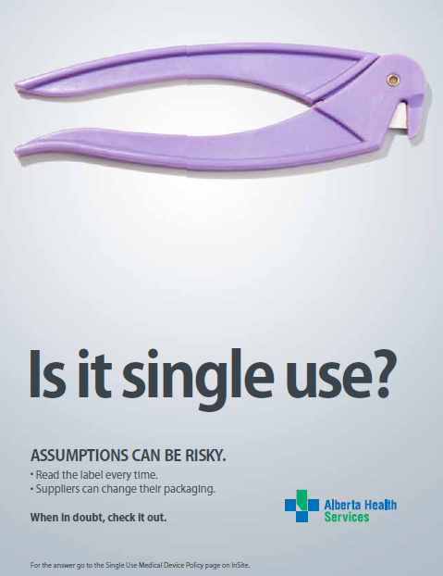 | YES  Cord Clamp Remover  - Check the manufacturer’s instructions for use  - Check the packaging  - Look for the single-use symbol:

