Our class will be participating in the school-based tobacco prevention program called The Academy for Tobacco Prevention. Over 5 lessons students will learn factual information, identify the harmful effects of tobacco use, learn to recognize unhealthy social situations, and practice ways to resist peer pressure to use tobacco products. Your child will also have an opportunity to play a cooperative card game with their peers as a way to develop valuable skills to resist negative tobacco industry influences.

**Your child may have questions or talk about what they are learning in class. We encourage students to talk to their parents! Here are some tips to help you talk to your child about tobacco.**

Learn more about The Academy for Tobacco Prevention go to [academy.albertaquits.ca](http://www.academy.albertaquits.ca)

**Don’t be fooled by tobacco in disguise.**

Tobacco is harmful no matter how it is used. Cigarettes are not the only way young people use tobacco. All of these products can have nicotine in them, even when the label says they don't. They can also have the same harmful chemicals that cigarettes do. Talk to your child about the importance of not using any type of tobacco.

**When To Bring It Up**

Plan to talk about tobacco many times throughout your child’s developing years.  Whenever you have time together, you can talk about tobacco.  It doesn’t have to be formal.  Some of the best times to talk might be when you are in the car, during meals, before bedtime, or during a walk.

**Know What Matters to Your Child**

Talk to your child about how using tobacco could affect things that are important to them. Use the list below to make your conversation personal.

* **Looking attractive:** People who use tobacco have yellow teeth, more wrinkles and bad breath.
* **Grades in school:** Younger people who use tobacco have lower grades in school.
* **Playing sports:** People who use tobacco have trouble breathing and slower reflexes.
* **Being healthy:** Young people who use tobacco have more health problems.
* **Making own decisions:** Tobacco companies go after young people to get them addicted for life.

Listen to what your child has to say about using tobacco.  Ask about the pressures they may be facing or how tobacco use in portrayed in the movies and on television.  Talk about what they could do if they were offered tobacco.  Let your child know they can tell you what is really happening and that you can help.  If you find out your child is using tobacco, don’t panic.  You are not alone, we can help.  Call AlbertaQuits at 1-866-710-QUIT (7848) or visit [albertaquits.ca](http://www.albertaquits.ca/).

**Keep Talking!**

**The pressures on a child to try tobacco continue from youth to adulthood.**

**Your first conversations shouldn’t be your last.**

| **Parent Letter**

Dear Parent or Guardian,

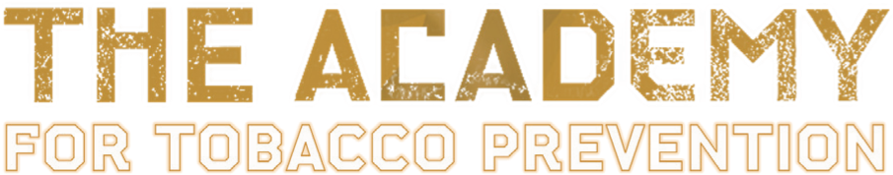

PARENT LETTER

