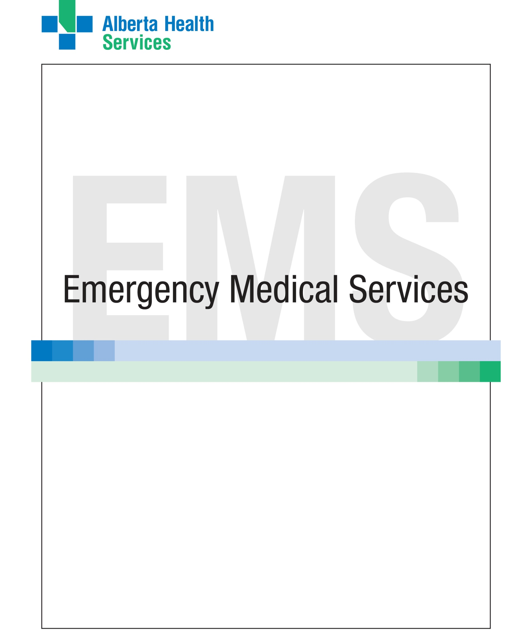

Requestor’s Summary Checklist for a Proposed EMS Research Study

Title of Proposed Research Study:
Date:

Section A: Overview of the Proposed Research Study
Information Area | Status  (place an X in the appropriate column) |  |  | Summary Details | Additional Comments (please add any comments that may not be included in the proposal)
 | Included in Proposal | Not Included in Proposal | Not Applicable | Refer to page and paragraph number in the attached proposal
A1. Research team members
A2. ARECCI* screening tool results (please attach)
A3. Confirmed sponsoring organization(s)
A4. Confirmed partner organization(s)
A5. Background information and/or previous related research (literature review)
A6. Clearly stated purpose of research
A7. Clearly stated research question(s) or hypothesis(es)
A8. Benefits for EMS patients and patient care
A9. Benefits for the EMS profession
*The ARRECI screening tool can be found at:
http://www.ahfmr.ab.ca/arecci/screening/12044/3996d23c31b3c4355a604dd4c34a3820

Section B: Methods of the Proposed Research Study
Information Area | Status |  |  | Summary Details | Additional Comments  (please add any comments that may not be included in the proposal)
 | Included in Proposal | Not Included in Proposal | Not Applicable | Refer to page and paragraph number in the attached proposal
B1. Duration of the research including start and finish dates
B2. Location(s) that will be required to collect data (e.g., Calgary metro, etc.)
B3. Study population, sample selection method, and sample size (including rationale and any calculations)
B4. Data collection methods
B5. Data storage methods
B6. Data analysis methods
B7. Patient-related data elements required (e.g., demographics, care provided, etc.)
B8. Non-patient-related data elements required (e.g., aggregate EMS data, etc.)

Section B: Methods of the Proposed Research Study continued...
Information Area | Status |  |  | Summary Details | Additional Comments  (please add any comments that may not be included in the proposal)
 | Included in Proposal | Not Included in Proposal | Not Applicable | Refer to page and paragraph number in the attached proposal
B9. Status of ethics approval and name of committee
B10. Strategy to protect the privacy of EMS patient, personnel, and other organizational data
B11. Process for EMS patient and/or personnel consent
B12. Risk(s) for EMS patients
B13. Risk(s) for EMS personnel
B14. Process for monitoring research findings (e.g., interim analyses, etc.)
B15. Process for providing research status reports (including urgent and emerging issues) to EMS
B16. Contingency plans for early shutting down or extension of the research (and availability of funding sources)

Section C: Knowledge Transfer/Dissemination of Proposed Research Study Findings
Information Area | Status |  |  | Summary Details | Additional Comments  (please add any comments that may not be included in the proposal)
 | Included in Proposal | Not Included in Proposal | Not Applicable | Refer to page and paragraph number in the attached proposal
C1. Plan(s) for publishing research findings
C2. Opportunity for EMS to be co-investigator/ co-author
C3. Plans for presentation of research findings to EMS
C4. Plans for external presentation of research findings
C5. Plans to assist EMS in translating study findings to action

Section D: Funding and Budget for the Proposed Research Study
Information Area | Status |  |  | Summary Details | Additional Comments  (please add any comments that may not be included in the proposal)
 | Included in Proposal | Not Included in Proposal | Not Applicable | Refer to page and paragraph number in the attached proposal
D1. Detailed study budget
D2. Confirmed funding (amount and source)
D3. Specify what costs you will cover as the researcher and what costs you are asking EMS to make as an in-kind contribution
D4. Process for reimbursing EMS for costs
D5. Contingency plans for obtaining additional necessary funding

Section E: EMS Personnel Requirements for the Proposed Research Study
Information Area | Status |  |  | Summary Details | Additional Comments  (please add any comments that may not be included in the proposal)
 | Included in Proposal | Not Included in Proposal | Not Applicable | Refer to page and paragraph number in the attached proposal
E1. The proposed role(s) of EMS personnel including EMS practitioners, EMS managers, EMS training personnel, EMS database personnel, and other EMS support personnel in the research
E2. The estimated number of EMS personnel required
E3. The proposed location(s) of EMS personnel
E4. The estimated time requirement for EMS personnel for training and study operation. Please specify time for EMS practitioners, EMS managers, EMS training personnel, EMS database personnel, and other EMS support personnel

Section E: EMS Personnel Requirements for the Proposed Research Study continued...
Information Area | Status |  |  | Summary Details | Additional Comments  (please add any comments that may not be included in the proposal)
 | Included in Proposal | Not Included in Proposal | Not Applicable | Refer to page and paragraph number in the attached proposal
E5. The proposed methods for training EMS personnel (e.g., on-line learning, classroom, simulation, etc.)
E6. The sources of on-going support for EMS personnel

