How to play

A great discovery occurred at the Enigma Hospital about the newest transmissible bacteria named Staphylococcus conundra, which interestingly has a very peculiar nosocomial property.

For some reason, the bacteria can only cause a new infection if it is located in a room that is either diagonally, horizontally, or vertically in line with another host.

Most hospitals have their rooms all down a hallway making isolating Staphylococcus conundra very difficult.

Enigma Hospital; however, has a particularly unique layout which, in this rare case, allows for the bacteria to potentially be accommodated for.

A unit at the Enigma hospital currently has 8 patients who have tested positive for Staphylococcus conundra, and each patient needs a separate room.

Take a look at the below map of Enigma Hospital, and see if you can place the 8 individuals in rooms so that none of the infected patients are diagonally, horizontally, or vertically beside each other.

Each square in the grid below represents a room in the hospital.

Place all 8 Staphylococcus conundra in such a way that they are not in line with each other diagonally, horizontally, or vertically.

IPC

Example 1
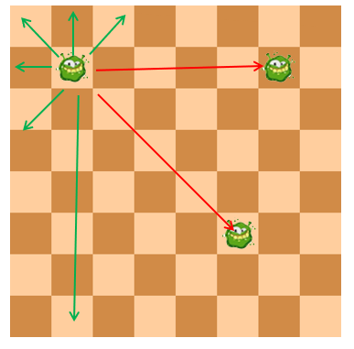
This example would not work as the host in the top left is diagonally across from the host at the bottom and horizontally from the host on the right.

Example 2
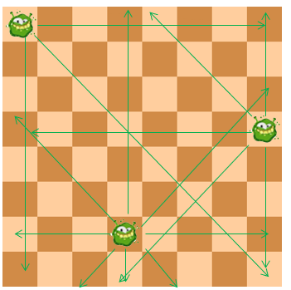
This example would work as these 3 hosts have been placed in such a way that they do not align vertically, horizontally or diagonally from each other, meaning they would not transmit.

Puzzle

Try placing all 8 hosts in rooms so that none of them are in line with each other horizontally, vertically, or diagonally.

Three hosts have been placed for you.

It may seem tough but it is possible.

Drag the images of the germs onto the grid to try to solve the puzzle.

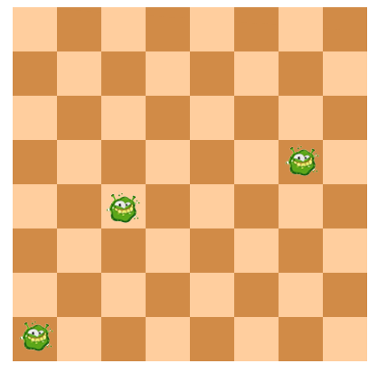

Need a hint?

View the Clean Your Hands Day 2022 Hints and Answer Key.

