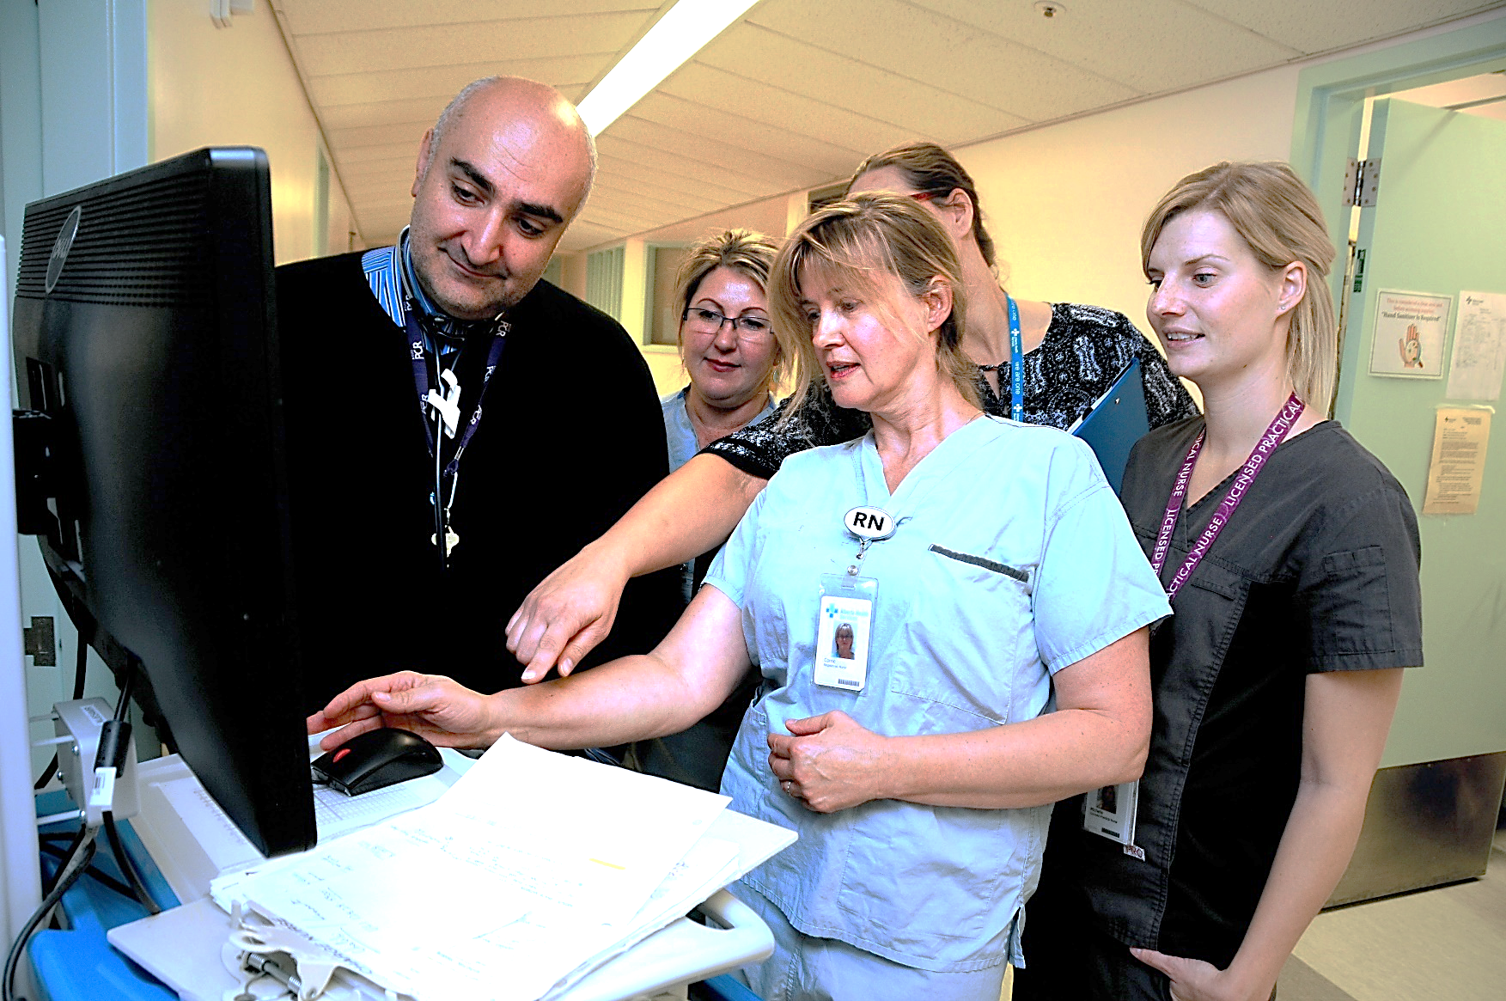



**Patent and Family Centred Care Week**

October 3-7, 2022

When everyone works together we accomplish amazing things. PFCC Week is a time to celebrate the successes of partnering with patients and families.

To find resources, share a favorite practice, and register for events:



Register for [*Together4Health*](https://together4health.albertahealthservices.ca/pfccinaction)



Visit [PFCC Week](https://www.albertahealthservices.ca/info/Page16748.aspx)