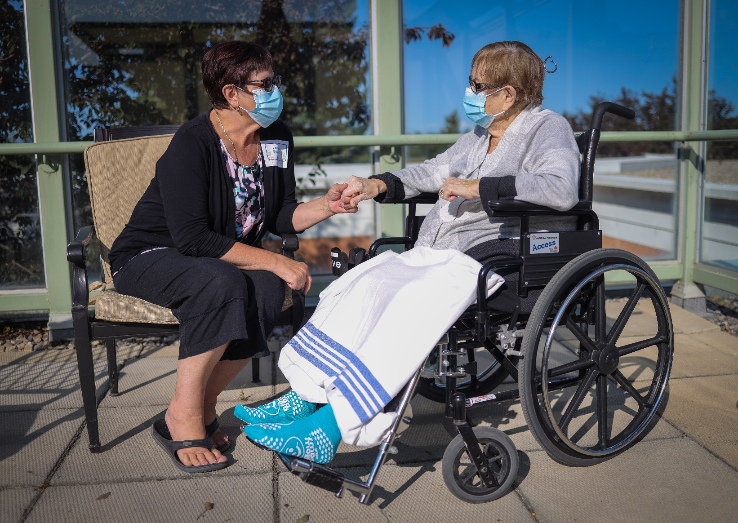





Visit [PFCC Week](https://www.albertahealthservices.ca/info/Page16748.aspx)

Register for [Together4Health](https://together4health.ahs.ca/pfccweek2020)

Join us as we honor patients and family/support persons to recognize patient and family centred care practices across AHS.

To find resources to celebrate the week and scheduled events:

Patient and Family Centred Care Week

November 2-6, 2020