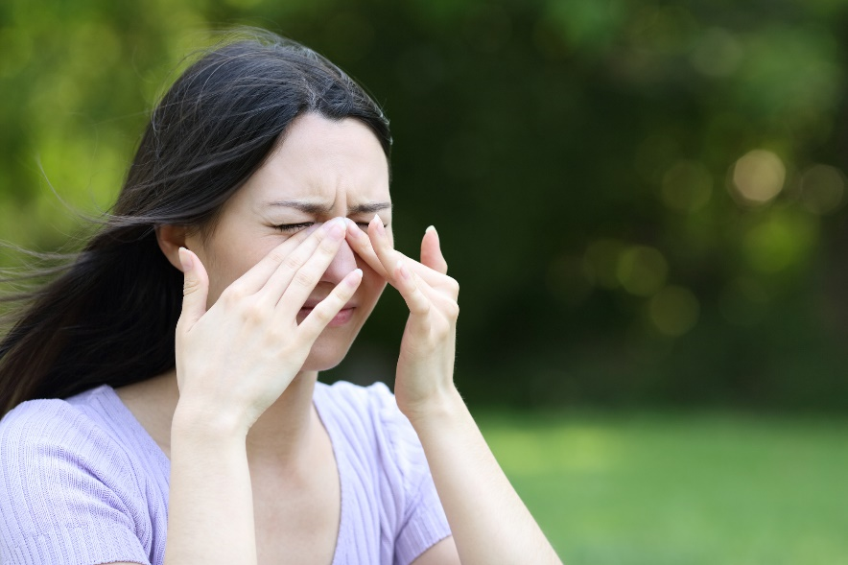
Managing Seasonal Allergies
Allergies occur when your immune system overreacts in response to certain substances, mistaking harmless elements as harmful germs or viruses. Numerous triggers can cause this to happen such as pollens, medicine, food, dust, animal dander, and mould.
If your allergy symptoms occur seasonally, it's likely due to an allergy to specific pollens from trees, grasses, or weeds.
Allergies can range from mild to severe, and some over-the-counter allergy medications may alleviate certain symptoms. Remember to carefully read and follow the instructions on medication labels.
Effectively managing your allergies is key to maintaining good health. Your healthcare provider might recommend tests to pinpoint the exact cause of your allergies. Once you identify your triggers, you can take steps to avoid them, which will help prevent allergy symptoms and potential health complications.
In some cases, immunotherapy could be beneficial. This treatment involves injections or pills containing small amounts of specific allergens. Over time, your body becomes desensitized to these allergens, resulting in reduced or prevented allergic reactions.

Symptoms and Treatment of Seasonal Allergies
Seasonal allergies can happen during any season and are very common. Some symptoms include:
- Itchy, watery eyes
- Sneezing
- Runny, stuffy, or itchy nose
- Temporary loss of smell
- Headache and fatigue
- Dark circles under the eyes ("allergic shiners")
- Drainage from the nose down the back of the throat (post-nasal drip)
- Sore throat, coughing, or snoring
Home treatments are usually all you need to treat seasonal allergies, depending on your symptoms. Medicines you can try for a stuffy nose include steroid nasal sprays, which can also help with red, itchy, watery eyes.
Other treatments include:
- Clean the inside of your nose with salt water to provide relief of a stuffy nose
- Use a humidifier in the bedroom and take hot showers to help clear a stuffy nose. Follow the directions for cleaning the humidifier
- If your nose is red and raw from rubbing, put petroleum jelly on the sore area
- Use over-the-counter allergy medicine to help your symptoms. Use a nasal or oral decongestant (such as Drixoral) to relieve a stuffy nose. For itchy, watery eyes; sneezing; or a runny, itchy nose, try a non-sedating over-the-counter antihistamine, like fexofenadine (such as Allegra) or loratadine (such as Claritin). To help relieve pain, try acetaminophen or ibuprofen

Preventing Seasonal Allergies
You can reduce your exposure to pollen and other allergens that cause seasonal allergies by:
- Keeping your house and car windows closed.
- Checking the Air Quality Health Index before you go outside.
- Limiting the time you spend outside when pollen counts are high (during midday and afternoon).
- Wearing a pollen mask or dust mask if you need to mow the lawn.
- Limiting your mowing tasks if you can.
- Rinsing your eyes with cool water or saline eyedrops to remove clinging pollen after you come indoors.
- Taking a shower and changing your clothes after you work or play outside.

v

Wellness Articles
Alberta Health Services encourages all Albertans to live a healthy life. These weekly Wellness Articles are created by a team of healthcare professionals from AHS in collaboration with
provincial healthcare experts in Alberta and content from myhealth.alberta.ca.
Our experts ensure this information is factual, current, and written for Albertans.
From stress-relief strategies to finding balance within your life, these Wellness Articles cover a
variety of different topics designed to inspire and educate Albertans on creating a positive and
healthy lifestyle.
We welcome and encourage weekly newspapers, community newsletters and other publications
to reproduce this information free of charge. Please credit Alberta Health Services or the identified
content provider.
If you would like to be added to the distribution list for these articles, please email: rebecca.johnson2@ahs.ca. You will receive a monthly email containing articles for the
upcoming four weeks.

