# All about low blood pressure

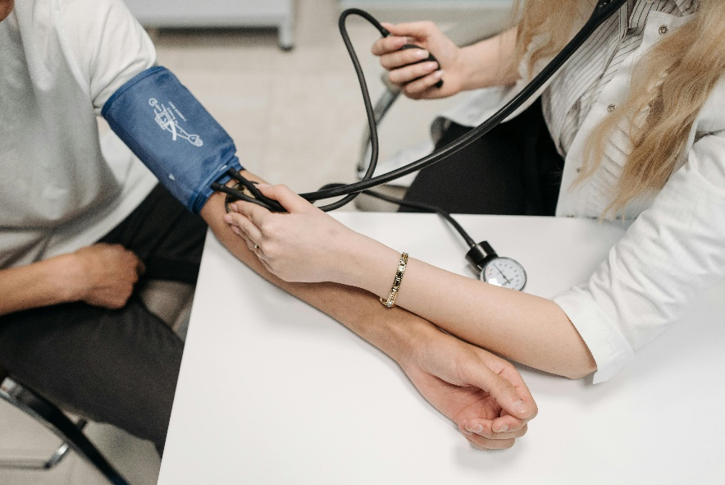Blood pressure is a measure of how hard blood pushes against the walls of your arteries as it moves through your body. Low blood pressure means that your blood pressure is lower than normal. It's also called hypotension.

In healthy adults, low blood pressure may not cause problems or symptoms. In fact, it may be normal for you. But if your blood pressure drops suddenly or causes symptoms like dizziness or fainting, it is too low.

In general, low blood pressure symptoms happen when blood pressure is less than 90/60.

## The causes of low blood pressure

Often people learn that they have low blood pressure when their doctor checks it. Or you may find that you have low blood pressure when you check it at home. To check for the causes of your low blood pressure, your doctor will ask about your past health, your symptoms, and the medicines you take. You will have a physical exam, and other tests may be done. Your doctor may check for another health problem that could be causing your low blood pressure.

Some causes of low blood pressure include:

* Getting up quickly after you sit or lie down. This can cause a quick drop in blood pressure called [orthostatic hypotension](https://myhealth.alberta.ca/health/pages/conditions.aspx?hwid=sto167548&lang=en-ca#sto167548-sec).
* Standing for a long time.
* Not drinking enough fluids ([dehydration](https://myhealth.alberta.ca/health/pages/conditions.aspx?hwid=std120726&lang=en-ca#std120726-sec)).
* Medicines. Examples are high blood pressure medicine or other heart medicines.
* Health problems. Examples are thyroid disease, severe infection, and neuropathy.
* Trauma. Examples are major bleeding and bad burns.

## Symptoms of low blood pressure

Many people with low blood pressure don't have any symptoms. Symptoms to watch for include:

* Feeling dizzy, light-headed, or faint.
* Feeling sick to your stomach or vomiting.
* Feeling more thirsty than usual.
* Having blurry vision.
* Feeling weak.
* Being confused.
* Being tired.
* Having cold, clammy skin.
* Breathing very fast.
* Having a fast heartbeat.

If you have symptoms of low blood pressure, especially dizziness or fainting, call your doctor. Watch for symptoms of low blood pressure. Tell your doctor when the symptoms happen so they can be treated.

## Prevention and treatment

Treatment depends on your symptoms and what's causing the low blood pressure. Your doctor may have you:

* Get fluid through an [intravenous (I.V.) line](https://myhealth.alberta.ca/health/pages/conditions.aspx?hwid=sti17216&lang=en-ca#sti17216-sec). This helps with dehydration.
* Change or stop medicines that lower your blood pressure.
* Take medicine to treat the problem that is causing low blood pressure. For example, you may need antibiotics to treat infection or medicines to stop vomiting or diarrhea.

Your doctor may suggest that you try some ways to prevent symptoms. To reduce dizziness, you might try standing up more slowly, drinking more water, or limiting alcohol. Other ways could include:

* Add more salt to your diet.
* Drink more water.
* Drink little or no alcohol.
* Wear compression stockings.

Be sure to talk with your doctor before you add more salt to your diet. If you feel dizzy or light-headed, sit down or lie down for a few minutes. Or you can sit down and put your head between your knees. This will help your blood pressure go back to normal and help your symptoms go away. If your doctor prescribes medicine to help prevent a low blood pressure problem, take it exactly as prescribed.

v

## Wellness Articles

Alberta Health Services encourages all Albertans to live a healthy life. These weekly Wellness Articles are created by a team of healthcare professionals from AHS in collaboration with   
provincial healthcare experts in Alberta and content from myhealth.alberta.ca.   
Our experts ensure this information is factual, current, and written for Albertans.

From stress-relief strategies to finding balance within your life, these Wellness Articles cover a   
variety of different topics designed to inspire and educate Albertans on creating a positive and   
healthy lifestyle.

We welcome and encourage weekly newspapers, community newsletters and other publications   
to reproduce this information free of charge. Please credit Alberta Health Services or the identified   
content provider.

If you would like to be added to the distribution list for these articles, please email: **rebecca.johnson2@ahs.ca**. You will receive a monthly email containing articles for the   
upcoming four weeks.