# Vending machines and healthy food choices

From going to work, attending school, or running errands, having a busy schedule can lead to eating more meals and snacks away from home. Foods eaten out of the house may include homemade dishes and snacks brought from home, or foods purchased from places like vending machines, convenience stores, cafes, and restaurants.

Often many of the foods prepared in restaurants and cafes or packaged foods like those found in vending machines contain higher amounts of salt (sodium), fat (saturated), and added sugars. Consuming these types of foods frequently and in large amounts may increase your risk of developing health conditions such as hypertension (high blood pressure), Type 2 Diabetes and heart disease.

Planning ahead and being prepared for the days when you know you will be eating outside of the house can help support a healthy eating pattern. If you can, bring a packed meal from home and try to have easy and nutritious snacks on hand such as vegetable sticks with hummus or No Bake Trail Mix. For these and other healthy snack recipes, visit ahs.ca/recipes and search ‘snacks’.

We know sometimes it is not possible to bring snacks and meals from home. However, it is important to make sure you are eating and staying hydrated throughout the day to keep your body energized. To provide food options for many workplaces, schools, and recreational facilities will have food and beverages available to buy from vending machines or concession stands.

## Making good choices!

If you find yourself in front of a vending machine in need of a snack, here are some tips you can use to help select healthier food choices:

* *Look for foods that contain protein, fibre, or vegetables and fruits*
  + 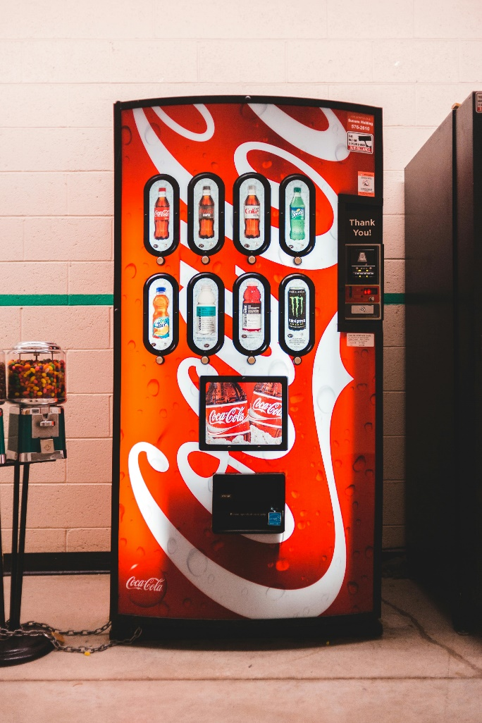Protein helps rebuild muscle and keeps you feeling full for longer. Protein foods include, trail mix, protein bars, tuna kits, reduced sodium jerky and dry roasted nuts, seeds and chickpeas.
  + Fibre can help reduce cholesterol and blood sugar levels, and may improve gut health. Vending machine options that contain fibre include whole grain crackers, granola bars, popcorn, and dried fruit bars.
  + Vegetables and fruits contain vitamins and minerals that help keep you healthy and often contain fibre. Vegetable and fruit choices include baked snap peas, dried fruit, apple chips, and unsweetened fruit cups or sauces.
* *Consider how the food was prepared*
  + Look for foods that were baked or roasted rather than fried such as baked crackers, potato, or rice crisps and roasted seaweed snacks.
  + Select nuts or popcorn without added salt or sweet coatings.

## Quenching your thirst

Try to make water your drink of choice, but if you are in the mood something different here are some healthier options you may find in a vending machine:

* Milk or fortified plant-based alternatives. Milk contains calcium, vitamin D, and protein which makes it a nutrient packed option. Some milk options have extra protein added.
* Flavoured sparkling water with no added sugars if you want something fizzy.
* Unsweetened tea or coffee.

## Looking for healthier options?

Everyone can contribute to creating a healthy food environment. Alberta Health Services has put together the Healthier Vending Toolkit which provides resources for advocating for healthy food options in vending machines and guidance on implementing healthier vending and snacks on sites like workplaces and recreational centres. You can find this toolkit by going to ahs.ca and typing Healthier Vending Toolkit in the search bar.

If you are interested in learning more about healthy eating where you live, work, learn and play go to healthyeatingstartshere.ca for more information.

v

## Wellness Articles

Alberta Health Services encourages all Albertans to live a healthy life. These weekly Wellness Articles are created by a team of healthcare professionals from AHS in collaboration with   
provincial healthcare experts in Alberta and content from myhealth.alberta.ca.   
Our experts ensure this information is factual, current, and written for Albertans.

From stress-relief strategies to finding balance within your life, these Wellness Articles cover a   
variety of different topics designed to inspire and educate Albertans on creating a positive and   
healthy lifestyle.

We welcome and encourage weekly newspapers, community newsletters and other publications   
to reproduce this information free of charge. Please credit Alberta Health Services or the identified   
content provider.

If you would like to be added to the distribution list for these articles, please email: **rebecca.johnson2@ahs.ca**. You will receive a monthly email containing articles for the   
upcoming four weeks.