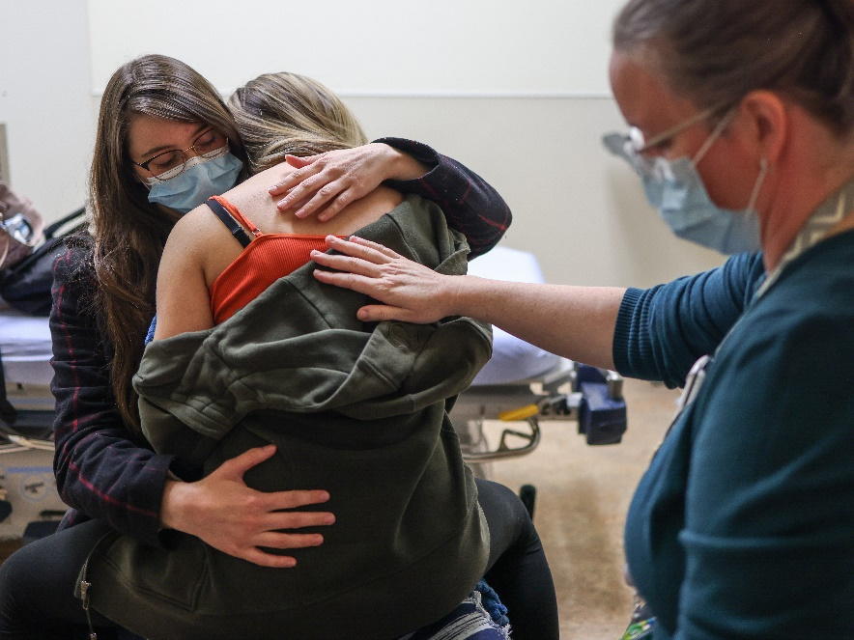
Preparing your school-age child for surgery
The hospital doesn’t have to be a scary place for your school-age child, even if they must undergo surgery.
Children from age six to 12 might be worried about many things ahead of their procedure, including having others see them cry or being scared, saying or doing something embarrassing, the surgery hurting or changing the way they look, or waking up during the surgery.
Parents and caregivers can take steps in preparing children and alleviating their worry and anxiety.
- Give them at least one to two weeks to prepare for the surgery. Tell them what will happen before, during, and after the surgery.
- Tell them they’ll get medicine from a doctor called an anesthesiologist to make sure they don’t feel anything or wake up during the surgery. If your child is worried about waking up during the surgery, read Anesthesia – frequently asked questions (FAQs) for kids to help you answer their questions.
- Be supportive and honest but treat your child as normally as possible. Being honest about the surgery can lessen your child’s fears and help them better understand what is going to happen.
- Explain things clearly and use words your child will understand. If you’re not sure how to answer a question, tell your child that you will find out the answer for them.
- It’s normal for school-age children to be angry or quiet before the surgery. Let them know that it’s okay they feel this way and encourage them to talk about how they’re feeling.
- Check for understanding. School-age children will listen carefully but may not understand what they hear. Have your child explain back to you what’s going to happen in the hospital. Talk about why they need to have surgery and what will happen.
- Ask your child’s friends to visit them in the hospital or to keep in touch with your child by phone, text, email, or cards.
- Make sure you or someone your child knows is with them at the hospital as much as possible.
- Give your child as many choices as possible as you get ready to go to the hospital. Help your child pack a few items from home such as a favourite stuffed animal, blanket, pillow, book, or toy.
It’s important to talk to your child about their surgery. It will help them feel less anxious if they know what to expect. It’s normal for your child to cry or to feel angry and frustrated but preparing them – and yourself – can help.

v

Wellness Articles
Alberta Health Services encourages all Albertans to live a healthy life. These weekly Wellness Articles are created by a team of healthcare professionals from AHS in collaboration with
provincial healthcare experts in Alberta and content from myhealth.alberta.ca.
Our experts ensure this information is factual, current, and written for Albertans.
From stress-relief strategies to finding balance within your life, these Wellness Articles cover a
variety of different topics designed to inspire and educate Albertans on creating a positive and
healthy lifestyle.
We welcome and encourage weekly newspapers, community newsletters and other publications
to reproduce this information free of charge. Please credit Alberta Health Services or the identified
content provider.
If you would like to be added to the distribution list for these articles, please email: rebecca.johnson2@ahs.ca. You will receive a monthly email containing articles for the
upcoming four weeks.

