# Back to School: Healthy eating for post-secondary students

Starting your first year at post-secondary is an exciting time. From attending orientation to finding the best place on campus to study, you will have many new experiences during the school year.

There are plenty of tips online about the best study methods to help you ace your exams, but did you know what you eat can also affect how well you do in school? Research shows that maintaining a healthy eating pattern may contribute to higher grade point averages in undergraduate students. Including a variety of vegetables and fruits, whole grains, and protein foods like chicken, fish, and beans in your meals and snacks can help provide your body and mind with the nutrients it needs to function at its best.

## Starting off on the right foot: Proper Equipment

If you moved away from home to attend school, you might be living on your own and preparing all your meals for yourself for the first time. Keep reading to find out what kitchen equipment you can use to prepare most dishes and some meal ideas to get you started.

Food skills are an important part of healthy eating. This includes knowing what foods to buy, where to buy them, and how to store and prepare food. The list below is a starting point that you can add to based on your budget and the types of foods you like to eat.

*Helpful kitchen equipment:*

* Medium-sized pot with a lid
* Non-stick frying pan
* Cutting boards – try to have at least two, one for raw meat and another for vegetables and fruit
* 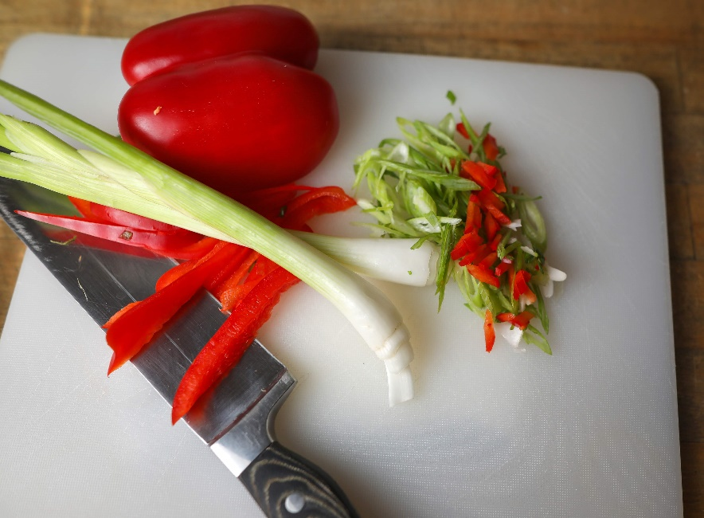Knife for chopping
* Spatula and tongs – silicone versions of these tools can prevent damage to protective coatings on pots and pans
* Can opener
* A set of measuring cups and spoons
* Mixing bowl
* Instant read food thermometer – important for checking that foods are fully cooked to help prevent foodborne illness
* Microwave safe food storage containers to store leftovers or bring food with you to campus to eat on the go

Having the equipment to prepare meals is the first step. Once you have settled into your new place, take the time to explore your neighborhood to find the closest food store.

Throughout the school year, you may find it takes a lot of time or energy to figure out what to cook every day. Meal planning can help you decide what to eat, help stay within your food budget and reduce food waste. Here are some quick meal ideas to fuel your brain and body.

Greek or Icelandic yogurt topped with whole grain cereal, fresh or frozen fruit, and nut or seed butter.

Burritos made with eggs, cheese, tomatoes, and green onions wrapped in a whole wheat tortilla. Add salsa to the eggs for extra flavour.

Add a protein food of choice like canned tuna, beans, or cooked chicken to a pre-made salad from the grocery store.

You can also use Canada’s food guide plate as a guide for building meals. Aim to make ½ your plate vegetables and fruit, ¼ whole grain foods, and ¼ protein foods. Along with healthy eating, hydration also contributes to your health. Try to make water your drink of choice. Keep a reusable water bottle with you to drink from throughout the day to help make it easier to stay hydrated. A healthy lifestyle also includes allowing 7–9 hours for sleep a night and making physical activity part of your routine to support your overall health.

Find more resources on healthy eating including meal planning, recipes, and shopping tips at HealthyEatingStartsHere.ca and search “Choose & Prepare Healthy Food.”

For information on food safety, including safe cooking temperatures, and general tips for handling, storing, and preparing food, check out the Food Safety page on Canada.ca.

v

## Wellness Articles

Alberta Health Services encourages all Albertans to live a healthy life. These weekly Wellness Articles are created by a team of healthcare professionals from AHS in collaboration with   
provincial healthcare experts in Alberta and content from myhealth.alberta.ca.   
Our experts ensure this information is factual, current, and written for Albertans.

From stress-relief strategies to finding balance within your life, these Wellness Articles cover a   
variety of different topics designed to inspire and educate Albertans on creating a positive and   
healthy lifestyle.

We welcome and encourage weekly newspapers, community newsletters and other publications   
to reproduce this information free of charge. Please credit Alberta Health Services or the identified   
content provider.

If you would like to be added to the distribution list for these articles, please email: **rebecca.johnson2@ahs.ca**. You will receive a monthly email containing articles for the   
upcoming four weeks.