# Protect your knees: Top Strategies for Preventing Knee Injuries

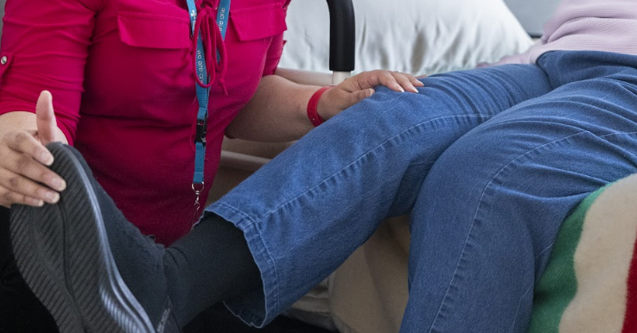Knee injuries can happen to anyone.

Sometimes issues develop from everyday wear and tear from jobs, sports, physical activities, having a disease such as osteoporosis or arthritis, or simply aging can increase your chances of having problems with your knees.

There are many ways to help reduce the risk of knee injuries – here are a few strategies to consider:

## Top tips for preventing knee injuries

* Stay at a healthy weight.
* Wear kneepads when kneeling on hard surfaces. Avoid prolonged kneeling.
* Avoid deep knee bends.
* Avoid running downhill unless you are fully conditioned.
* Wear shoes with good arch supports.
* Always do a warm-up before physical activities such as five to 10 minutes of light jogging or riding a stationary bicycle.
* Make stretching part of your warm-up before the activity and your cool-down after the activity. Stretching can help you keep and improve your range of motion and reduce stiffness in your joints.

## Strength training and conditioning

Strengthening your leg muscles can greatly reduce the risk of knee injuries. Pay special attention to your front and back thigh muscles (quadriceps and hamstrings).

**Try these strength training activities:**

* **Agility**. Learning to crouch and bend at the knees and hips when turning may reduce the stress on your knees. Agility exercises include running forward and backward and running in diagonals (run diagonally to one spot, then cut the other way and run to another).
* **Jumping and spinning.** On the same spot, bend your knees and jump into the air. Spin one-quarter turn (90 degrees) to the right and land on both feet. Repeat to the left. Advance how much you spin to a half turn, three-quarters turn, and full turn.
* **Tuck jumps.** On the same spot, jump straight up with your hands at your side. As you jump, bring your knees up toward your chest. Repeat immediately 10 times.
* **Hopping.** You will need a small object to hop over for this exercise. You can start with a small object like a book or even a piece of tape along the floor. Place the object or tape on the floor to your left, and hop over it using both legs. Then hop back to your right. Hop back and forth over the object 20 times. You may also hop back and forth on one leg.
* **Landing skills**. When landing after jumping always remember to:
  + Land with the knees bent. As the knees bend during landing, make sure they travel in a straight path. Do not let them move closer together.
  + Land softly on the balls of the feet and roll back onto the heels.
  + Keep your knees and hips aligned and your upper body upright. Don't bend too far forward or backward as you land.
  + Try not to land on one foot. If this is not possible, bring the other foot down as soon as possible to distribute weight evenly.

v

## Wellness Articles

Alberta Health Services encourages all Albertans to live a healthy life. These weekly Wellness Articles are created by a team of healthcare professionals from AHS in collaboration with   
provincial healthcare experts in Alberta and content from myhealth.alberta.ca.   
Our experts ensure this information is factual, current, and written for Albertans.

From stress-relief strategies to finding balance within your life, these Wellness Articles cover a   
variety of different topics designed to inspire and educate Albertans on creating a positive and   
healthy lifestyle.

We welcome and encourage weekly newspapers, community newsletters and other publications   
to reproduce this information free of charge. Please credit Alberta Health Services or the identified   
content provider.

If you would like to be added to the distribution list for these articles, please email: **rebecca.johnson2@ahs.ca**. You will receive a monthly email containing articles for the   
upcoming four weeks.