# Making lifestyle changes after a health scare

If you have recently had a health scare, your doctor has likely indicated that lifestyle changes are necessary for your new way of life. Whether it’s getting active, eating better, or prioritizing your health, goal setting can help you take the steps you need to keep you on the right path.

If you are ready to make a change, it can help to start with one or two goals and break them down into smaller steps. Change can be hard, especially if we try to make too many changes at once. You are more likely to reach smaller goals.

You can use the [Setting goals for lifestyle change worksheet](https://www.albertahealthservices.ca/assets/info/nutrition/if-nfs-setting-goals-lifestyle-change.pdf) to set a goal that’s important to you and that you can reach. You are the expert in your life and the best judge of what will work for you.

The goal-setting worksheet guides you through the following steps:

1. Choose a goal that is important to you.
2. Break your goal into smaller goals.
3. Make your goal SMART.
4. Finish your plan by thinking about
   * things that might get in the way of your goal;
   * people who can help you;
   * ways to track your progress

## Three-day food and activity journal

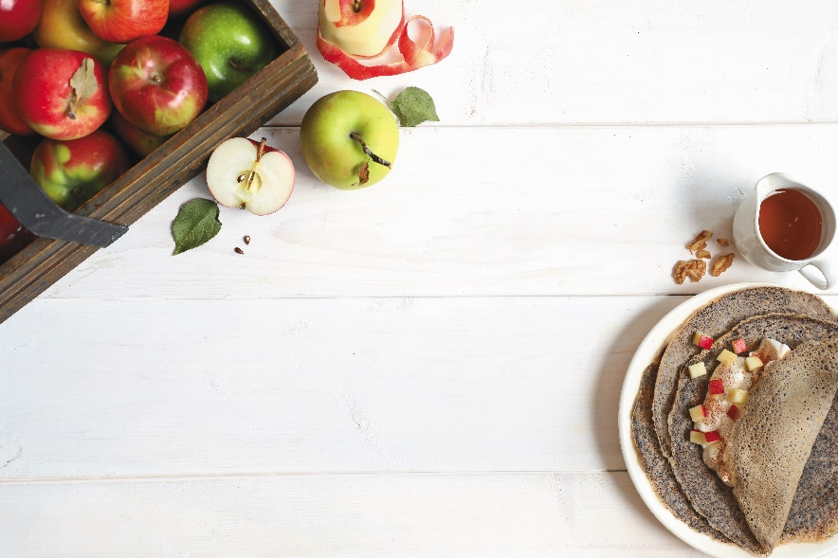Use this journal as a tool to help you meet your eating goals. When you review your journal, you can see the progress you’ve made, or you may decide to make new goals.

**​​​How to fill in the journal**

* Print or save the [3-Day Food and Activity Journal](https://myhealth.alberta.ca/Alberta/Alberta%20Images/3_Day_Journal.pdf).
* Write down everything you eat and drink. You may want to record **one weekday** (or **workday**) and **one Saturday**or **Sunday(**or **day off)**.
* Include:
  + How much food you ate. See the suggestions below to estimate portion sizes. If the food comes in a package, just write down the package size. Example: 175 mL container of yogurt.
  + ​How the food is cooked (for example: fried, baked, boiled, barbecued)
  + Anything you add to food, during or after cooking. Example: cream, sugar, oil, butter, jam, syrup, ketchup or other sauces, dressings or condiments.
  + Details about restaurant foods, fast foods, or packaged foods (for example: McDonald’s Big Mac® or KFC® chicken).
* Measure the food you eat for a day or two to help you understand how much you eat and drink. Use measuring cups and spoons.
* Write down all your **activities**for the day. Include planned activities (going for a walk or swim) and activities of daily life (housework or grocery shopping). Comments may include where you ate, your mood, or stress level.
* Print more copies of the journal if you need more space to write.
* Read over your journals to see what is working well and what you may want to change.
* Keep on tracking. Use this tool to help you meet your goals, or to make new goals.
* **To estimate portion sizes, use the guidelines below:**

|  |  |
| --- | --- |
| **This amount of food:** | **Is about the same size as:** |
| 2½ oz (75g) of meat | a hockey puck |
| 1½ oz (50 g) of cheese | 2 white erasers |
| 1 cup (250 mL) | a baseball or fist |
| ½ cup (125 mL) | a hockey puck |
| 1 medium piece of fruit | a tennis ball |
| 2 Tbsp (30 mL) | 1 golf ball |
| ¼ cup (60 mL) | 2 golf balls |
| 1 tsp (5 mL) – use for butter, margarine, mayonnaise | a thumb tip or one die |

**Example of how to fill in your food journal:**

|  |  |  |
| --- | --- | --- |
| **Meal** | **Day 1: Thursday** | **Day 2: Saturday** |
| **Breakfast (First Meal)** | * 1 cup Bran Flakes® with 1 tsp sugar and ½ cup 1% milk * 1 cup coffee black * 1 slice whole wheat toast with 2 tsp soft margarine | * 1 egg fried in 1 tsp butter with 3 strips of bacon * 2 slices whole wheat toast with 2 tsp soft margarine * 2 cups tea (chamomile) |
| **Snack** | * 1 carrot muffin - Tim Hortons® * 1 medium black coffee - Tim Hortons® | * 1 medium apple |
| **Activity** | * Stressful day at work | * 30 minute walk |

Download the [3 Day Food and Activity Journal](https://myhealth.alberta.ca/Alberta/AlbertaDocuments/3-day-food-activity-journal.pdf).

v

## Wellness Articles

Alberta Health Services encourages all Albertans to live a healthy life. These weekly Wellness Articles are created by a team of healthcare professionals from AHS in collaboration with   
provincial healthcare experts in Alberta and content from myhealth.alberta.ca.   
Our experts ensure this information is factual, current, and written for Albertans.

From stress-relief strategies to finding balance within your life, these Wellness Articles cover a   
variety of different topics designed to inspire and educate Albertans on creating a positive and   
healthy lifestyle.

We welcome and encourage weekly newspapers, community newsletters and other publications   
to reproduce this information free of charge. Please credit Alberta Health Services or the identified   
content provider.

If you would like to be added to the distribution list for these articles, please email: **rebecca.johnson2@ahs.ca**. You will receive a monthly email containing articles for the   
upcoming four weeks.