# Breast cancer awareness and screening

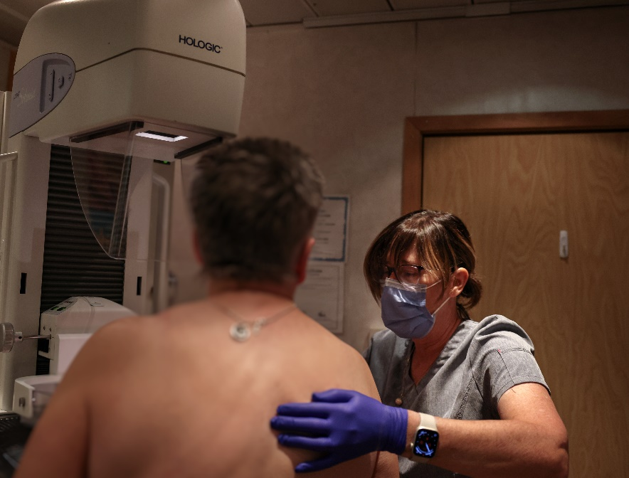Breast Cancer Awareness Month is underway. If you’re [45-74](https://www.youtube.com/watch?v=SvhLYe6MIYg) years of age, it’s a great time to check that breast cancer screening is part of your regular health routine.

Breast cancer is the most common cancer found in women. It’s the second leading cause of female cancer deaths. About 1 in 7 Alberta women will have breast cancer in their lifetime.

Get checked for breast cancer by having a **screening mammogram** once every two years if you are between the ages of 45 and 74, or as decided by you and your healthcare provider.

## Reduce Your Risk

You can lower your chances of getting breast cancer by adding these to your daily routine:

* Be physically active at least 150 minutes a week, or 20 minutes each day, even if it’s a brisk walk or some yard work.
* Eatlots of fruits and vegetables. [Canada’s Food Guide](https://food-guide.canada.ca/en/) recommends that fruits and vegetables make up half of what you eat every day.
* Limit how much [alcohol](https://www.ccsa.ca/canadas-guidance-alcohol-and-health) you drink. Drinking less is better for your health.
* Consider [quitting commercial tobacco](https://albertaquits.healthiertogether.ca/) use and avoid second-hand smoke. Talk to your healthcare provider or visit [AlbertaQuits.ca](https://albertaquits.healthiertogether.ca/) for information and supports that are best for you.

## What is a screening mammogram?

A screening mammogram is an x-ray of the breast. The goal of screening mammograms is to find breast cancer early, which is when treatment is most effective.

During a screening mammogram, your breasts will be compressed (flattened) to get the best image possible. This may be uncomfortable or slightly painful, but tolerable. Each compression only lasts a few seconds, so any discomfort will be very short.

If you are between the ages of 45 and 74, plan to have a screening mammogram once every two years, or as decided by you and your healthcare provider. If you are in this age range, you don’t need a referral from your doctor. To find screening locations, visit [screeningforlife.ca](https://screeningforlife.ca/) and select “where to get screened” on the top right. Use the [locator](https://screeningforlife.ca/where-to-get-screened/) tool to search “Breast”.

For people who are transgender, gender diverse, or non-binary, consider having screening mammograms regularly if you have breast tissue. This includes if:

You’ve taken gender affirming hormones (like estrogen) to increase the size of your breasts for 5 or more years in total. The years do not have to be back-to-back.

You haven’t had top surgery to remove breast tissue, even if you’ve had a hysterectomy or are taking testosterone. Testosterone therapy isn’t believed to significantly increase the risk (chance) of breast/chest cancer.

## Screening in rural communities

Screen Test is a service that brings screening mammography to 120 rural communities using two mobile clinics, free of charge. To find out when the next mobile clinic is in your area, go to [screeningforlife.ca/mobile-services](https://screeningforlife.ca/mobile-services/) or call 1-800-667-0604 (toll free).

## Spreading awareness

Breast Cancer Awareness Month takes place every year in October, and aims to raise awareness around breast cancer prevention, early detection, treatment and support.

Visit [screeningforlife.ca/breast](https://screeningforlife.ca/breast) to learn more about breast screening and Screen Test mobile clinics.

Always see your healthcare provider if you notice changes in your breast. Symptoms of breast cancer may include a new lump, thickening of the skin, bloody nipple discharge or inverting of the nipple.

Alberta Health Services welcomes people of every sex, gender identity and sexual orientation to screen for breast cancer. Before getting screened, it is recommended to speak with your healthcare provider about your personal cancer risk level and whether screening is right for you.

v

## Wellness Articles

Alberta Health Services encourages all Albertans to live a healthy life. These weekly Wellness Articles are created by a team of healthcare professionals from AHS in collaboration with   
provincial healthcare experts in Alberta and content from myhealth.alberta.ca.   
Our experts ensure this information is factual, current, and written for Albertans.

From stress-relief strategies to finding balance within your life, these Wellness Articles cover a   
variety of different topics designed to inspire and educate Albertans on creating a positive and   
healthy lifestyle.

We welcome and encourage weekly newspapers, community newsletters and other publications   
to reproduce this information free of charge. Please credit Alberta Health Services or the identified   
content provider.

If you would like to be added to the distribution list for these articles, please email: **rebecca.johnson2@ahs.ca**. You will receive a monthly email containing articles for the   
upcoming four weeks.