# Helping your child manage stress

Children and teens notice and react to stress in their family and feel their own stress. It is important to recognize stress in children and teens and help them with healthy coping strategies. The strategies they learn often stay with them into adulthood.

In general, anything that may cause children fear and anxiety can cause stress. This can include being away from home, starting a new school or moving to a new location, being separated from parents or caregivers, worrying about school and getting along with others, worrying about their changing bodies, and worrying about the future.

## Watching for signs of stress in children and teens

There are many ways children and teens experience stress and it can often look different than it does in adults.

***Preschool and toddlers:***

* Anger
* Anxiety
* Problems with eating and sleeping, including nightmares
* Fear of being alone
* Irritability
* Regressing to infant behaviours
* Trembling with fright
* 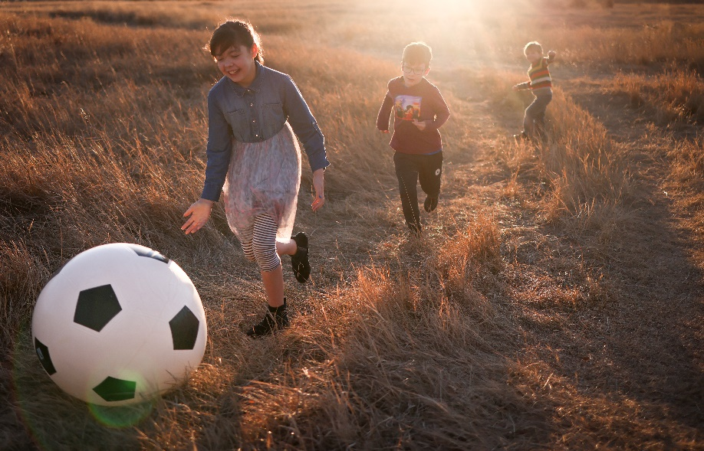Uncontrollable crying
* Withdrawal

***Elementary-age children:***

* Being distrustful
* Complaining of headaches or stomach aches
* Feeling unloved
* Having no appetite
* Having trouble sleeping
* Needing to urinate often
* Wetting the bed
* Not caring about school or friendship
* Acting withdrawn
* Worrying about the future

***Preteens and teens:***

* Anger
* Disillusionment
* Distrust of the world
* Low self-esteem
* Stomach aches and headaches
* Panic attacks
* Rebellion

## What can you do to help?

Parents and caregivers can play a big role in reducing stress in children. Some of the ways you can help include:

* **Acknowledge your child's feelings.** When children seem sad or scared, for example, tell them you notice that they are sad or scared. If appropriate, reassure them that you can understand why they would feel sad or scared.
* **Build trust.**Let your child know that mistakes are learning experiences.
* **Be supportive.** Listen to your child's concerns. Allow your child to try to solve their own problems, if you can. But offer to help and be available to your child when they need you.
* **Show love, warmth, and care.** Hug your child often.
* **Have clear expectations** without being too strict. Let your child know that co-operation is more important than competition.
* **Don't over-schedule your child** with too many activities.
* **Provide a good example.**Keep calm and express your anger in appropriate ways. Think through plans to reduce stress and share them with your family.
* **Teach about consequences.** Children need to learn about the consequences—good and bad—of their actions. For example, if they do all of their chores on time, they will get their allowance. If they break another child's toy, they must find a way to replace it.
* **Encourage healthy thinking.** Help your child understand what is fantasy and what is reality. For example, help your child see that their behaviour didn't cause a divorce.
* **Provide your child with some control.** Allow your child to make choices within your family framework. For example, let your child arrange their room, choose family activities, and help make family decisions.

## Relieving stress in healthy ways

Try some of these stress reducing tips and notice big changes in your child, preteen, or teen:

* **Exercise.** Regular exercise is one of the best ways to manage stress. For children, this means activities like walking, bike-riding, outdoor play, and solo and group sports.
* **Write or draw.** Older children often find it helpful to write about the things that bother them. Younger children may be helped by drawing about those things.
* **Let feelings out.** Invite your child to talk, laugh, cry, and express anger when they need to.
* **Reduce screen time.** Instead, encourage your child to do something else they enjoy, like playing board games, practicing a hobby or spending time with friends. Volunteer work or work that helps others can be a great stress reliever for older children.
* **Learn ways to relax.** This can include breathing exercises, muscle relaxation exercises, meditating, praying, or yoga.
* **Laugh.** Laughter really can be the best medicine. You can be a good role model in this area by looking for the humour in life. Your child can learn this valuable skill by watching you.
* **Eat healthy foods.** Encourage your child to form healthy habits, including choosing healthy foods.

v

## Wellness Articles

Alberta Health Services encourages all Albertans to live a healthy life. These weekly Wellness Articles are created by a team of healthcare professionals from AHS in collaboration with   
provincial healthcare experts in Alberta and content from myhealth.alberta.ca.   
Our experts ensure this information is factual, current, and written for Albertans.

From stress-relief strategies to finding balance within your life, these Wellness Articles cover a   
variety of different topics designed to inspire and educate Albertans on creating a positive and   
healthy lifestyle.

We welcome and encourage weekly newspapers, community newsletters and other publications   
to reproduce this information free of charge. Please credit Alberta Health Services or the identified   
content provider.

If you would like to be added to the distribution list for these articles, please email: **rebecca.johnson2@ahs.ca**. You will receive a monthly email containing articles for the   
upcoming four weeks.