# Protecting your bones for a healthier future

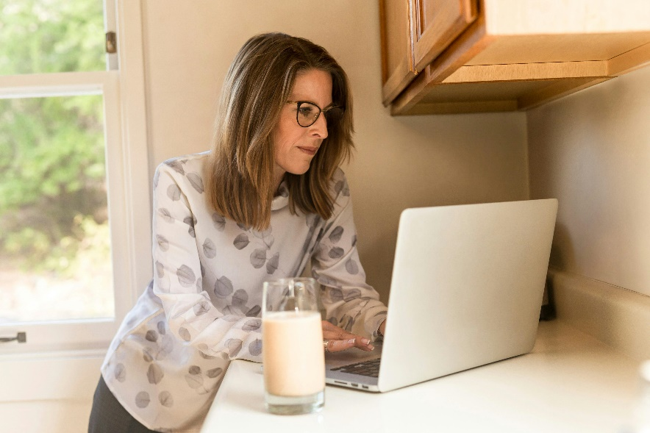November is Osteoporosis Month in Canada, a great time to focus on bone health. Osteoporosis is a disease that affects over 2.3 million Canadians. At least one in three women and one in five men will suffer from a broken bone caused by osteoporosis during their lifetime. Understanding and knowing how to prevent and manage osteoporosis can help you reduce your risk of fractures (breaking bones).

## What is osteoporosis?

Osteoporosis is a disease where bones become brittle and weak. This makes them more likely to break, even from minor events. The most common places for osteoporosis-related fractures to occur include the wrist, shoulder, spine and hip. This can lead to a reduction in mobility and quality of life. Osteoporosis is often called the “silent thief” because bone loss happens gradually, often without noticeable symptoms until a fracture occurs.

## The causes of osteoporosis

Human bones are constantly being broken down and rebuilding themselves. As we age, we start to lose more bone than we make. In osteoporosis, bone loss occurs more rapidly than normal, leading to a loss of bone quantity (or mass) and strength. While there is no single cause identified, the following can increase the risk of osteoporosis:

* Older age
* Gender
* Genetics
* Early menopause
* Use of certain medications

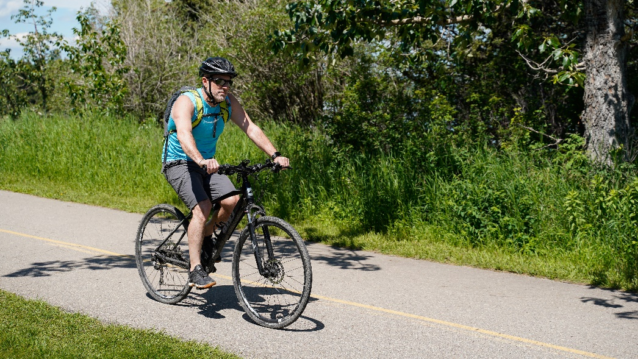

* Having a medical condition such as thyroid conditions, hormone disorders, rheumatoid arthritis, celiac disease, conditions that affect the absorption of foods, chronic liver or lung disease
* Low body weight
* Consuming three or more alcoholic drinks each day
* Using commercial tobacco products
* Having an inactive lifestyle

## How is osteoporosis diagnosed?

Your doctor will look at several factors, including the risk factors listed above, as well as any changes in your height and whether you have broken a bone in the past, to help determine if you are at risk of developing osteoporosis. They may also ask you to have a test, called a bone mineral density test, to determine how thick or thin your bones are.

## Preventing and managing osteoporosis

You can start taking steps to improve your bone health today. Talk to your doctor about your fracture risk and if medication might be warranted to reduce your risk of breaking a bone. Taking care of our bone health is important for everyone, whether we have osteoporosis or not. Below are examples of things we can do to protect our bones.

* **Move more and sit less.** Do exercises you enjoy while following Canada's 24 Hour Movement guidelines. This would include: 1) Moderate to vigorous physical activity which accumulates up to 150 minutes per week 2) Strength training twice per week 3) several hours of light activity per day including standing and stretching. Doing so can have a positive impact on functional abilities and fall prevention.
* **Eat a variety of healthy foods everyday including vegetables and fruits, whole grains and protein rich foods.** These foods will help give you the energy and protein your body needs to support function and health. Protein helps to build and repair bones. Include protein foods at every meal. Some examples of protein foods are beans, lentils, tofu, eggs, yogurt, fish, poultry and meat.
* **Get enough calcium.** Ensure you are consuming enough calcium. Good sources of calcium include dairy products like milk, hard cheeses and yogurt as well as fortified foods like soy milk. Spread your calcium-containing in foods intake throughout the day for better absorption.
* **Take a Vitamin D supplement.** Vitamin D can be obtained from sunlight and foods like fatty fish and fortified dairy products, however most Canadians require supplementation.
* **Limit caffeine.** More than 400 mg of caffeine in a day may be linked to higher rates of bone loss. Each 8 oz (250 mL) cup of coffee can have up to 150 mg of caffeine.
* **Reduce sodium.** Too much sodium prevents calcium absorption. Keep intake to below 2,300 mg sodium a day which is roughly 1 tsp (5 mL) of salt. Most sodium we eat comes from processed, pre-packaged and restaurant foods and added salt from cooking or the table. Check the nutrition facts table to see how much sodium a food contains. A per cent Daily Value of 5 per cent or less is a little sodium, while 15 per cent or more is a lot. Aim for 5 per cent or less where possible.
* **Drink less alcohol.** More than 2 drinks a day increases your risk of breaking a bone. Drinking less is better. One drink is 5 oz (142 mL) of wine, 12 oz (341 mL) beer, cider, cooler, or 1 ½ (43 mL) oz of spirits/distilled alcohol.
* **Prevent falls.** Falling is not a normal part of aging. Seek help from your primary healthcare provider if you have two or more falls per year. A fall is where there is an injury or if you experience a disturbance in balance or how you walk. A fall could be caused by such things as low blood pressure, vertigo, vision and hearing changes, medication changes, foot/nail care, worries about falling, seizure disorders or osteoarthritis.
* **Stop smoking or reduce commercial tobacco use.** Smoking increases your risk of developing osteoporosis. Older adults who smoke are 30 to 40 per cent more likely to break their hips than those who do not smoke. The good news is that fracture risk is reduced in those who give up smoking. Alberta Quits is a free, web-based smoking cessation program including online, texting, and counselling services and supports designed to help people who want to quit smoking or those using spit tobacco to find the support and tools they need. Find out more at [AlbertaQuits.ca](https://albertaquits.healthiertogether.ca/).

## Learn more and take action!

Have a conversation with your doctor about your fracture risk. To learn more about eating well for your bones visit ahs.ca/nutritionhandouts, search Am I Eating Well for my Bones. For more information about exercise, visit osteoporosis.ca/too-fit-to-fracture.

Taking proactive steps for your bone health can help reduce your risk for osteoporosis related fractures. This November, consider adopting habits that support strong, healthy bones.

v

## Wellness Articles

Alberta Health Services encourages all Albertans to live a healthy life. These weekly Wellness Articles are created by a team of healthcare professionals from AHS in collaboration with   
provincial healthcare experts in Alberta and content from myhealth.alberta.ca.   
Our experts ensure this information is factual, current, and written for Albertans.

From stress-relief strategies to finding balance within your life, these Wellness Articles cover a   
variety of different topics designed to inspire and educate Albertans on creating a positive and   
healthy lifestyle.

We welcome and encourage weekly newspapers, community newsletters and other publications   
to reproduce this information free of charge. Please credit Alberta Health Services or the identified   
content provider.

If you would like to be added to the distribution list for these articles, please email: **rebecca.johnson2@ahs.ca**. You will receive a monthly email containing articles for the   
upcoming four weeks.

## Subhead goes here

Text goes here.