# Managing and preventing kidney stones

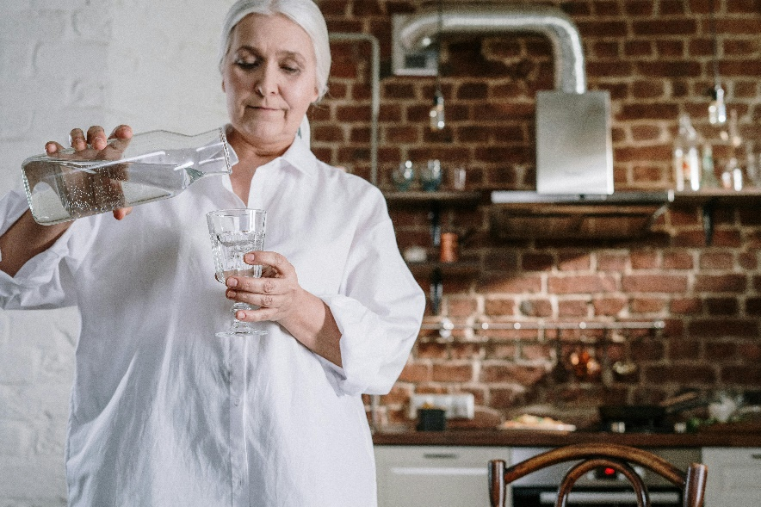What are kidney stones?

A kidney stone forms when salts and minerals that would normally pass out of the body in the urine build up in large amounts and separate from the urine to form crystals.

When the urine leaves the kidney, it may carry the crystal out, or the crystal may stay in the kidney and over time several smaller crystals combine to form a kidney stone.

They can be as small as a grain of sand or grow to be as large as a golf ball.

## Causes and risk factors

Several things can affect your risk for getting kidney stones. These include:

* **How much fluid you drink.** The most common cause of kidney stones is not drinking enough water. Kidney stones form when a change occurs in the normal balance of water, salts, minerals, and other things in urine. When you don't drink enough these substances can build up and stick together to form the crystals that eventually become kidney stones.
* **Your diet.** Diets high in protein and sodium increase your risk for kidney stones. So do oxalate-rich foods, such as dark green vegetables.
* **Being overweight.** This can cause both insulin resistance and increased calcium in the urine, which can increase your risk for kidney stones.

Your age, gender, and whether you have a family history of kidney stones can also affect your risk. But these things are out of your control.

## Symptoms

* Sudden, severe pain that gets worse in waves. Stones may cause intense pain in the back, side, abdomen, groin, or genitals.
* Nausea and vomiting.
* Blood in the urine.
* 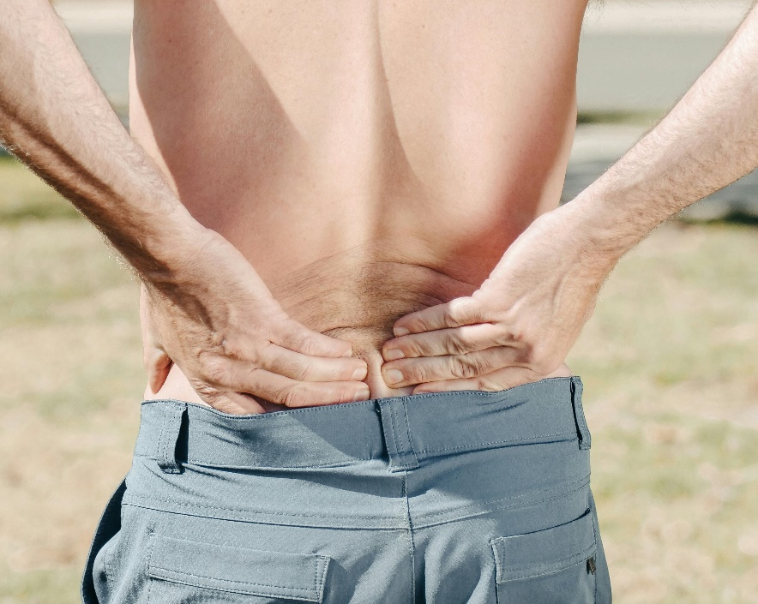Frequent and painful urination.

## Treatment

For most kidney stones, your doctor will recommend home care, such as pain medicine and drinking plenty of water. You may get a medicine to help the stone pass. If it is too large to pass, you may need other treatment, such as one that uses shock waves to break the stone into small pieces.

## Prevention

The following tips may lower your chance of getting kidney stones or from getting them again:

* Drink plenty of water.
* Eat less salt and salty foods.
* Increase your [fibre](https://myhealth.alberta.ca/health/Pages/conditions.aspx?hwid=stf15573&lang=en-ca" \l "stf15573-sec) consumption.
* Avoid grapefruit juice.
* Drink lemonade made from real lemons (not lemon flavouring). It is high in citrate, which may help prevent kidney stones.

If you have had kidney stones, your doctor or dietitian may talk with you about an eating plan to help prevent new stones. Talk to your health care professional about:

* **Oxalate.** Limiting certain foods that have a lot of oxalate, such as dark green vegetables, nuts, and chocolate may help prevent kidney stones.
* **Animal protein in your diet.** This includes beef, chicken, pork, fish, and eggs. These foods contain a lot of protein, and too much protein may lead to kidney stones.
* **Natural health products**. Your doctor may want you to limit how much fish liver oil, calcium, and vitamin C and D supplements you take.

v

## Wellness Articles

Alberta Health Services encourages all Albertans to live a healthy life. These weekly Wellness Articles are created by a team of healthcare professionals from AHS in collaboration with   
provincial healthcare experts in Alberta and content from myhealth.alberta.ca.   
Our experts ensure this information is factual, current, and written for Albertans.

From stress-relief strategies to finding balance within your life, these Wellness Articles cover a   
variety of different topics designed to inspire and educate Albertans on creating a positive and   
healthy lifestyle.

We welcome and encourage weekly newspapers, community newsletters and other publications   
to reproduce this information free of charge. Please credit Alberta Health Services or the identified   
content provider.

If you would like to be added to the distribution list for these articles, please email: **rebecca.johnson2@ahs.ca**. You will receive a monthly email containing articles for the   
upcoming four weeks.