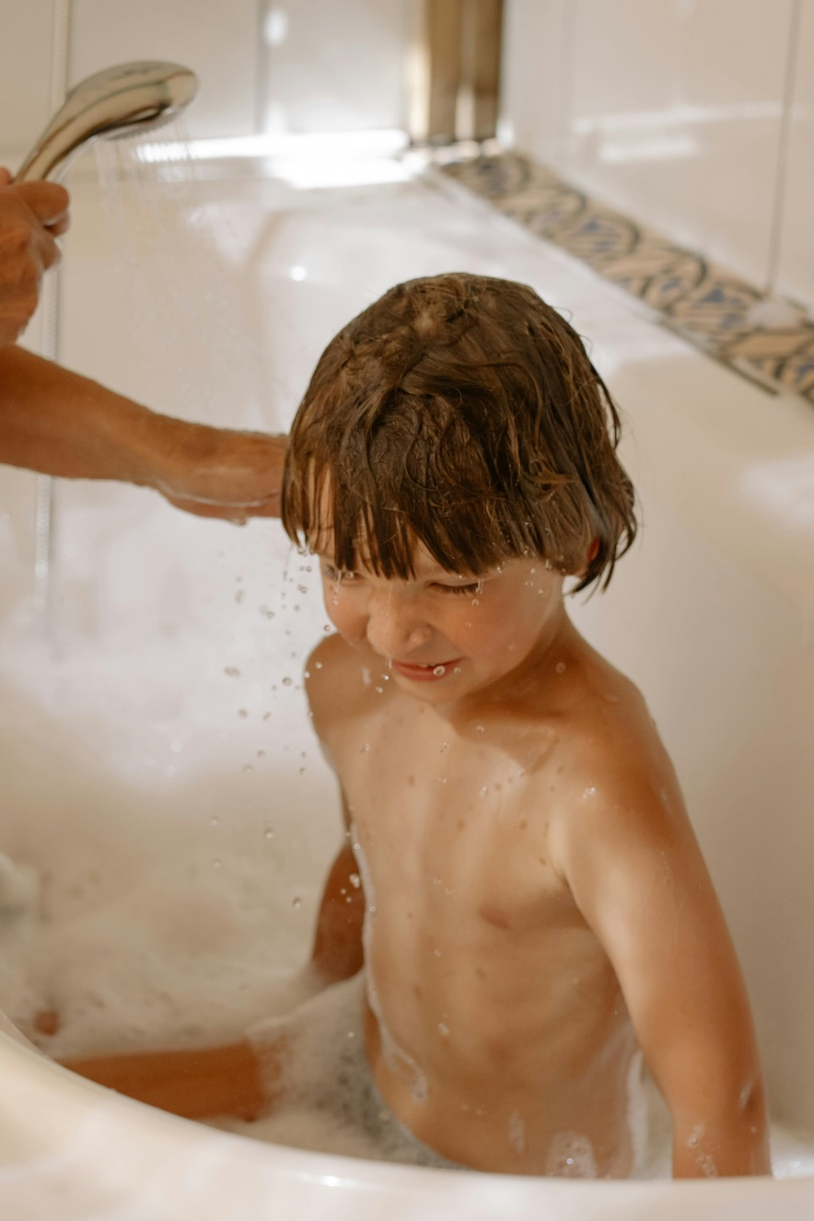
Watching for Head Lice
Head lice are tiny insects that live close to the scalp, where they lay and attach their eggs (nits).
Head lice are most common in children and typically spread anytime a child's head is in contact with the head or hair of someone else who has lice.
There are common misconceptions and stigma around head lice. These are a few important points to remember about head lice:
• They are not dangerous
• They do not spread disease
• They do not have anything to do with how clean someone is
• They cannot survive unless they are close to the scalp
• They cannot fly or jump

Symptoms
Head lice may cause an itchy feeling on the scalp. This is because of your body's reaction to the lice bites. But not everyone has itching, and not all itching means you have lice. Lice can be on the scalp for four to six weeks before itching starts.

Diagnosis

You can check for head lice at home. Under a bright light, use a fine-toothed comb and part small sections of hair to look for live lice and eggs (nits). Using a magnifying glass can help too. It may be easiest to find them on the back of the neck at the hairline or behind the ears.

Live lice are tan to greyish white. They're about the size of a sesame seed. Nits look like tiny yellow or white dots attached to the hair, close to the scalp. They're often easier to see than live lice. Nits may look like dandruff, but you can't pick them off with your fingernail or brush them away.

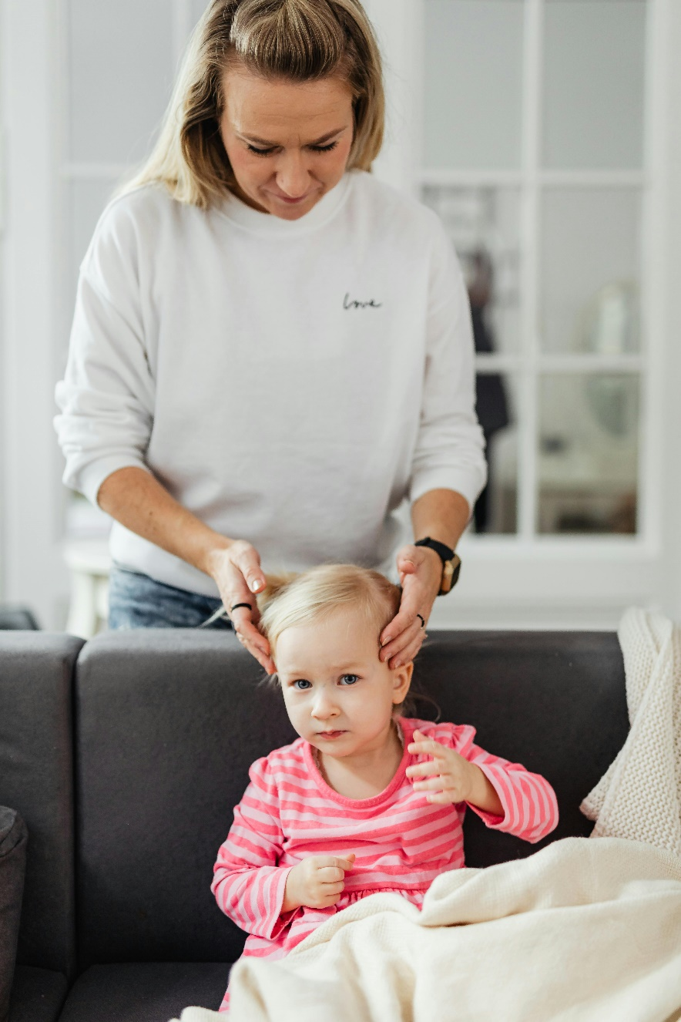
Treatment
There are several over-the-counter medicines that kill lice. Most of them are creams or shampoos that you put on the scalp. Each type of medicine is a little different, so it's important to follow the directions carefully. Your doctor or pharmacist can help you choose a medicine that is safe.

You may also want to try wet-combing, which can help physically remove the lice and nits. Use a comb with teeth that are close together. You can also find special lice combs in pharmacies.

Remember to check your scalp for live, active lice 12 hours after treatment. If you find any, talk to your doctor. You may need a different type of treatment.

Prevention
Check everyone in your home for lice. If your child shares a bed with someone, the other person should be treated too. (Don't worry about pets. They can't get lice.) Teach your children not to share anything that comes into contact with hair. For example, don't share hair bands, towels, helmets, hats, combs, or brushes.

You don't need to spend a lot of time or money deep cleaning your home. But it's a good idea to:
- Soak hairbrushes, combs, barrettes, and other items for 10 minutes in hot water.
- Machine-wash clothes, bedding, towels, and hats that touched the head in the last 2 days in hot water. Dry them in a hot dryer. If you don't have access to a washing machine or if items can't be washed or dried, store these items in a sealed plastic bag for 14 days.
- Vacuum carpets, mattresses, couches, and other upholstered furniture.

v

Wellness Articles
Alberta Health Services encourages all Albertans to live a healthy life. These weekly Wellness Articles are created by a team of healthcare professionals from AHS in collaboration with
provincial healthcare experts in Alberta and content from myhealth.alberta.ca.
Our experts ensure this information is factual, current, and written for Albertans.
From stress-relief strategies to finding balance within your life, these Wellness Articles cover a
variety of different topics designed to inspire and educate Albertans on creating a positive and
healthy lifestyle.
We welcome and encourage weekly newspapers, community newsletters and other publications
to reproduce this information free of charge. Please credit Alberta Health Services or the identified
content provider.
If you would like to be added to the distribution list for these articles, please email: rebecca.johnson2@ahs.ca. You will receive a monthly email containing articles for the
upcoming four weeks.

