# Winter Sun Safety: Protecting yourself year-round

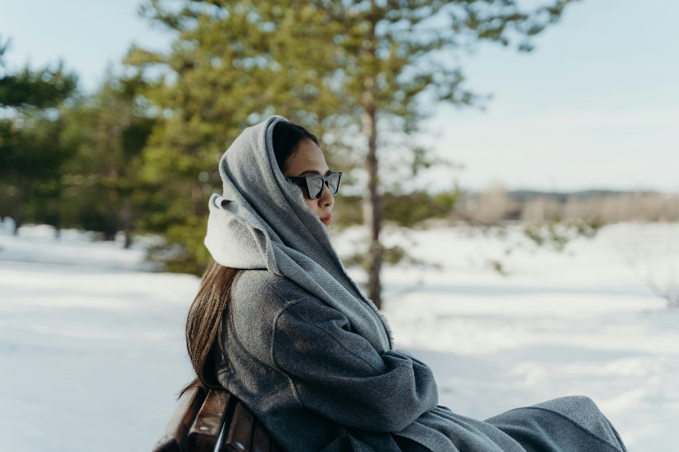When winter arrives, many people living in Alberta may stop thinking about sun safety. However, ultraviolet radiation (UVR) can still pose a health risk, even in the chilly months.

UVR comes from the sun but is invisible to humans. Two of the three forms of ultraviolet light, UVA and UVB rays, reach the earth and can harm you.

Around 65 to 90 per cent of all skin cancers are linked to UVR exposure. Melanoma is the most serious type of skin cancer. In Alberta, around one in 42 males and one in 46 females will develop melanoma within their lifetime. From those who develop melanoma, around one in 276 males and one in 674 females will die.

## Ultraviolet radiation reflects off the snow

During winter, UVR can be as harmful as in the summer. The [UV Index](https://weather.gc.ca/forecast/public_bulletins_e.html?Bulletin=fpcn48.cwao) is a rating of how strong the sun’s rays are. The higher the UV rating, the more careful you have to be when outside in the sun.

When skiing, snowshoeing, walking or skating, you can be exposed to more UVR than you think. Bright white surfaces like snow can double your UVR exposure. Being at a higher altitude can also expose you to more UVR, putting you at higher risk of sun damage.

Protect yourself from the sun during the winter by following these tips:

* Check the [UV index](https://weather.gc.ca/forecast/public_bulletins_e.html?Bulletin=fpcn48.cwao) (a rating of how strong the sun’s rays are) when planning to be outside in the sun. If the UV index is above 3, be careful. Consider planning activities in the shade, away from the sun.
* Wear winter clothing that covers as much skin as possible. Most winter clothing will provide good UV protection because of tight windproof construction with multiple layers.
* Some areas that are not always covered by winter clothes are your face, head and hands. 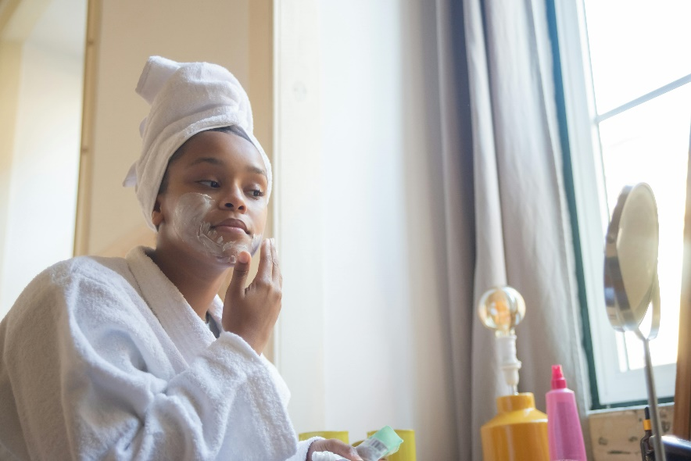Choose a sunscreen that has a broad-spectrum sun protection factor (SPF) of 30 or higher. Apply sunscreen generously 20 minutes before going outside and reapply frequently.
* Wear sunglasses that fit closely and wrap around the face. Try to find sunglasses that reflect or filter out 99-100% of UVR light.
* [Find out](https://www.canada.ca/content/dam/hc-sc/migration/hc-sc/ewh-semt/alt_formats/hecs-sesc/pdf/pubs/climat/actue_care-soins_actifs/actue_care-soins_sante-eng.pdf) if your medication causes you to be more sensitive to sunlight or heat stress.

## Escaping to warmer weather? Stay sun safe!

While a sunny destination escape is exciting, you might be caught off guard by how strong the sun’s rays are in certain climates. Bringing sunscreen, long sleeve shirts and clothing with good UV protection, hats, sunglasses and other measures can help protect your skin and eyes from short- and long-term damage from the sun.

A “base tan” from either indoor tanning (also known as tanning beds) or outdoor tanning before a trip will **NOT** prevent a sunburn. In fact, it’s estimated that indoor tans only give you two to four percent protection from the sun. Tanning equipment usually emits higher levels of UV radiation than the UV radiation outside. Use of tanning beds is not worth the health risks.

***Did you know?*** The World Health Organization has placed UV tanning beds into its highest cancer risk category, ranking tanning beds equal to well-known carcinogens like asbestos and tobacco.

## Skin types: what is yours?

The colour of your skin also plays a role in your sun burn risk. The fairer your skin is, the higher the risk. It's important that you know what your skin type is and understand the risks.

|  |  |  |
| --- | --- | --- |
| **Risk level** | **Skin type** | **How skin reacts to sun** |
| HIGH | Light, pale white | Always burns, never tans |
| HIGH | White, fair | Usually burns, tans with difficulty |
| MEDIUM | Medium, white to olive | Sometimes mild burn, gradually tans to olive |
| MEDIUM | Olive, moderate brown | Rarely burns, tans with ease to moderate brown |
| LOW | Brown, dark brown | Very rarely burns, tans very easily |
| LOW | Black, very dark brown to black | Almost never sunburn, tans very easily |

[Nevi](https://myhealth.alberta.ca/Health/aftercareinformation/pages/conditions.aspx?hwid=uh4963#:~:text=Most%20moles%20are%20harmless%20and,or%20changes%20size%20or%20colour.) are benign melanocytic tumours, also known as moles. They are strongly associated with risk for melanoma. The greater the number of moles on a person's skin, the greater the risk of melanoma. Someone who has more than 100 common moles or more than two atypical moles has a five- to twenty-fold increased risk of melanoma.

Learn more about your skin type and the risks of indoor tanning by visiting: <https://www.healthiertogether.ca/living-healthy/limit-uv-rays/indoor-tanning/>

Learn more about skin cancer screening and skin self-exam:

* <https://www.canadianskincancerfoundation.com/early-detection/skin-check/>
* <https://myhealth.alberta.ca/Health/pages/conditions.aspx?hwid=skc1179>

v

## Wellness Articles

Alberta Health Services encourages all Albertans to live a healthy life. These weekly Wellness Articles are created by a team of healthcare professionals from AHS in collaboration with   
provincial healthcare experts in Alberta and content from myhealth.alberta.ca.   
Our experts ensure this information is factual, current, and written for Albertans.

From stress-relief strategies to finding balance within your life, these Wellness Articles cover a   
variety of different topics designed to inspire and educate Albertans on creating a positive and   
healthy lifestyle.

We welcome and encourage weekly newspapers, community newsletters and other publications   
to reproduce this information free of charge. Please credit Alberta Health Services or the identified   
content provider.

If you would like to be added to the distribution list for these articles, please email: [**rebecca.johnson2@ahs.ca**](mailto:rebecca.johnson2@ahs.ca). You will receive a monthly email containing articles for the   
upcoming four weeks.