# Learning about Polycystic Ovary Syndrome (PCOS)

Polycystic Ovary Syndrome (PCOS) is a common condition that is caused by a hormonal imbalance. Hormones control the activity of different cells and organs in your body. With PCOS, the hormone imbalance can affect your period and your overall health. It causes the ovaries to produce higher levels of the hormone testosterone. With PCOS, your ovaries may also develop enlarged, fluid-filled [follicles](https://myhealth.alberta.ca/Health/pages/conditions.aspx?hwid=hw226883&) that are often referred to as cysts.

Because of the extra testosterone, people with PCOS may have:

* missed periods, irregular periods, and very light periods (including spotting)
* extra hair on the face or body
* thinning hair on the head
* severe acne
* difficulty managing weight
* difficulty getting pregnant
* darkening of skin on the neck, armpits, or groin area

If you notice sudden, unusual hair growth on your face or body or new wide purple stretch marks on your body, contact your healthcare provider right away.

You may also have symptoms of:

* [sleep apnea](https://myhealth.alberta.ca/Health/pages/conditions.aspx?hwid=sts14918&)
* fatigue
* 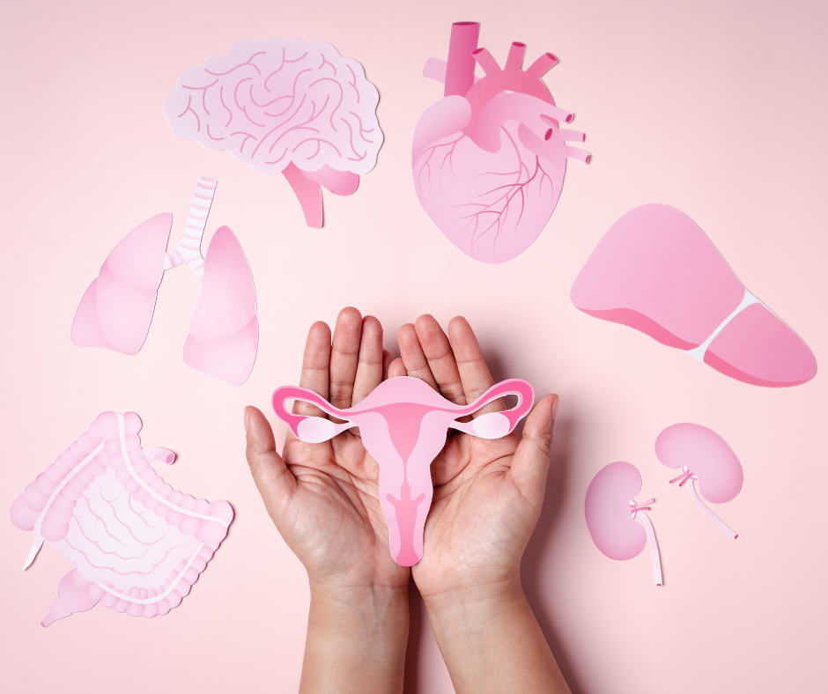anxiety, depression, and mood changes
* high blood pressure, high blood glucose, and high blood lipids (your healthcare team can test for these things)

People living with PCOS may be at an increased risk of sleep apnea, diabetes, heart disease, pregnancy complications, and [endometrial hyperplasia](https://myhealth.alberta.ca/health/AfterCareInformation/pages/conditions.aspx?HwId=acc9012).

## Visit your healthcare provider

It’s important to consult your healthcare provider about PCOS. Write down how you feel, your symptoms, when your symptoms started, what makes your symptoms better or worse, and any concerns you have. Make a list of questions and concerns. During your appointment, your healthcare provider may ask you several questions about your health history and your family’s health history.

They may ask about your:

* menstrual cycle
* past pregnancies or attempts to get pregnant
* unwanted hair growth
* symptoms
* weight management
* medicines and supplements
* ethnicity

These questions help your healthcare provider diagnose PCOS and know how to best support you and your overall health.

Your healthcare provider will also check your height, weight, and blood pressure. Because PCOS can increase your risk of diabetes and heart disease, knowing your current height, weight, and blood pressure will help your healthcare team manage these risk factors and also manage your PCOS symptoms.

Your healthcare provider may also do an exam to check for signs of high testosterone levels, insulin resistance, and other conditions. This exam includes:

* Looking for skin tags and dark, thick, velvety skin in your body folds and creases.
* Looking for extra hair in different parts of your body, especially on your face and chin. You may want to delay shaving, plucking, or doing any hair removal before your appointment.
* Looking for wide purple stretch marks in your belly area and other parts of your body.

Work with your healthcare team to decide what is best for you as you manage your PCOS and find resources and services in your community:

* [211 Alberta](https://ab.211.ca/) helps people in Alberta find the right resource or service for whatever issue they need help with. 211 is available any time, day or night, by phone (call 211), text, and online chat. It is confidential and available in over 170 languages over the phone.
* The [Alberta Healthy Living Program](https://www.albertahealthservices.ca/info/page13984.aspx) has workshops, classes, and services to improve your health and quality of life.
* The Alberta Health Services [Chronic Disease Management program](https://www.albertahealthservices.ca/info/page11934.aspx) has links and resources to help people living with chronic conditions.

v

## Wellness Articles

Alberta Health Services encourages all Albertans to live a healthy life. These weekly Wellness Articles are created by a team of healthcare professionals from AHS in collaboration with   
provincial healthcare experts in Alberta and content from myhealth.alberta.ca.   
Our experts ensure this information is factual, current, and written for Albertans.

From stress-relief strategies to finding balance within your life, these Wellness Articles cover a   
variety of different topics designed to inspire and educate Albertans on creating a positive and   
healthy lifestyle.

We welcome and encourage weekly newspapers, community newsletters and other publications   
to reproduce this information free of charge. Please credit Alberta Health Services or the identified   
content provider.

If you would like to be added to the distribution list for these articles, please email: [**rebecca.johnson2@ahs.ca**](mailto:rebecca.johnson2@ahs.ca). You will receive a monthly email containing articles for the   
upcoming four weeks.