# Getting active in the New Year

The New Year is a perfect opportunity to embrace healthier habits and prioritize well-being. You can start today.

Start by finding activities you enjoy, whether it’s jogging, swimming, lifting weights, or joining a fitness class. Make movement a regular part of your routine. Although adding more activity to your life may seem overwhelming, it helps to start small. Make one lifestyle change that helps you move more regularly at an effort level that matches your current condition.

## One step at a time

Walking is a great way to be active. For most people, walking is a safe activity, and it helps make the bones stronger and keep the joints healthy. It can make you feel less tired and can put you in a good mood. To help get into the habit of walking, try wearing a pedometer for a day or even a week. At the start, you might be surprised to see how few steps you take each day. To boost your daily step count, make simple changes in your daily routines like:

* Park a few blocks away from work and walk.
* Take the stairs instead of escalators or elevators.
* Walk in your neighbourhood before or after supper. Start with short walks and slowly increase the distance. Set new goals when you’re ready.
* Invite a friend or family member to join. You may find you can walk longer when you walk with another person.

Remember, some activity is better than none. The more you do, the better. Finding activities you 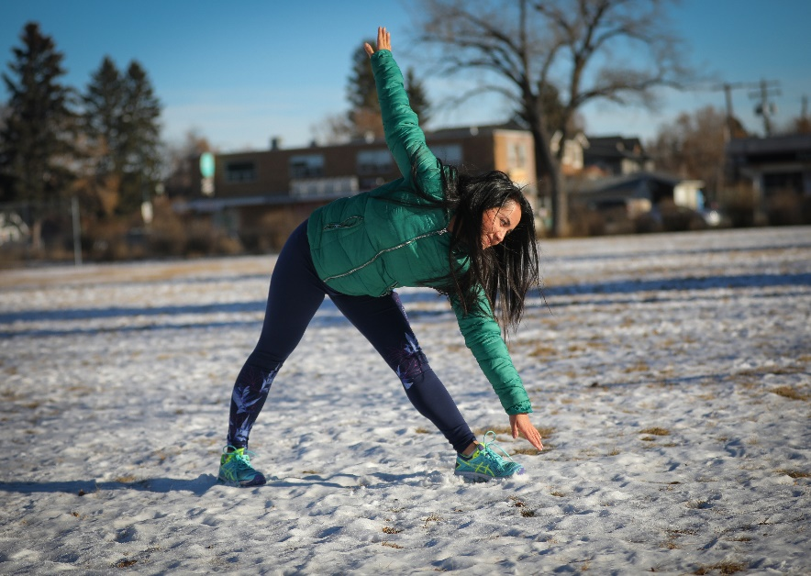enjoy and that are practical is an important first step to becoming active.

## Get outside!

Spending more time being active outdoors offers many benefits like boosting your mental health, increasing energy, or lowering your risk of diabetes, heart disease, and some types of cancer. Although Alberta winters can be difficult because of the shorter days, cold weather, and snow and ice, there are many reasons to still get outside. Check out hard-to-reach places on snowshoes or skis or go skating outside. Being outdoors more can also make you feel good about your community.

## It doesn’t have to be hard

Most people who dance, swim, play tennis, or go hiking do these activities because they enjoy them. Having fun is good for your health. Taking part in an activity that you enjoy will help you relax and help lower your stress. It will help you feel good about yourself, which is good for your mental health. Physical activity doesn’t have to be hard to be good for your body. If you don’t like going to a gym, do something outside or walk in a mall.

***What activity appeals to you?*** Try to find an activity you enjoy doing by yourself or with others. If you like what you’re doing you’ll probably keep doing it. Find out about activities in your community to try new things and learn new skills.

***Physical activity can help you live better as you grow older.*** Staying active will help you reach, bend, lift, carry, and move around easier, so you can keep doing things you like to do. The more you sit or lie around, the stiffer your joints get. Stretching and strength exercises will keep your muscles and joints moving and help stop falls and injuries.

***Being active is safe for most people.*** Start slowly and work your way up. If you aren’t sure about how much activity you can do, talk to your healthcare provider.

***Physical activity doesn’t need to be dull or boring.*** Do activities you enjoy more often. You may be surprised how quickly you start to feel stronger and like you have more energy.

v

## Wellness Articles

Alberta Health Services encourages all Albertans to live a healthy life. These weekly Wellness Articles are created by a team of healthcare professionals from AHS in collaboration with   
provincial healthcare experts in Alberta and content from myhealth.alberta.ca.   
Our experts ensure this information is factual, current, and written for Albertans.

From stress-relief strategies to finding balance within your life, these Wellness Articles cover a   
variety of different topics designed to inspire and educate Albertans on creating a positive and   
healthy lifestyle.

We welcome and encourage weekly newspapers, community newsletters and other publications   
to reproduce this information free of charge. Please credit Alberta Health Services or the identified   
content provider.

If you would like to be added to the distribution list for these articles, please email: **rebecca.johnson2@ahs.ca**. You will receive a monthly email containing articles for the   
upcoming four weeks.