# Preventing Cervical Cancer

January is Cervical Health Awareness Month, a time to learn about cervical cancer — how to prevent or find it early.

Alberta Health Services (AHS) recommends cervical cancer screening once every three years, or as your healthcare provider recommends, for women and people with a cervix between the ages of 25 and 69 who are or have been sexually active.

A Pap test checks for abnormal cells in your cervix, which can lead to cervical cancer. Pap tests can also check if you already have cervical cancer. The earlier cancer is found, the easier it is to treat. Regular Pap tests and follow-up care can prevent about 90 per cent of cervical cancer cases.

It’s important to have regular Pap tests, even if:

* You feel healthy and have no symptoms of cervical cancer
* You’ve only had one sexual partner
* You’ve had the human papillomavirus (HPV) vaccine
* You’ve been through menopause
* You’re no longer sexually active
* You’re a lesbian, bisexual or queer woman

## Human papillomavirus (HPV) immunization

HPV is a virus. It is the most common sexually transmitted infection and can cause genital warts and certain cancers. An HPV infection will often go away on its own. However, some people get a long-term infection. This can lead to cancer of the vagina, vulva, cervix, penis, anus, mouth, or throat. **HPV causes almost all cervical cancers.**

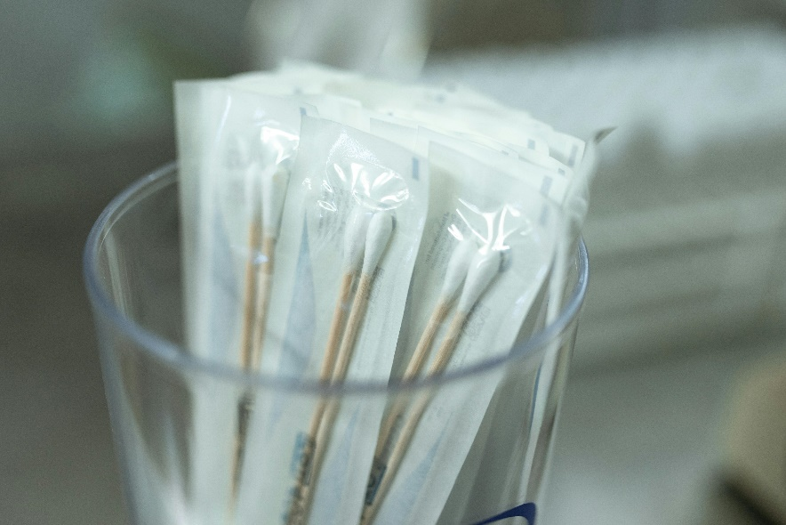You can prevent cervical cancer by getting immunized with the [HPV-9 vaccine](https://myhealth.alberta.ca/topic/immunization/pages/hpv-9-vaccine.aspx). The HPV-9 vaccine protects against 9 strains (types) of HPV. Some of these strains may cause up to 92% of cervical cancers.

Grade 6 students can get the HPV-9 vaccine as part of the school immunization program. Students can only be immunized in school with a parent or caregiver’s permission (consent).

If you did not get the HPV-9 vaccine in Grade 6, you can still get it for free up to and including age 26 years. Talk to your doctor to find out if it is a good idea for you. If you are unsure about getting the HPV vaccine for yourself or your child, try the [HPV Vaccine Decision Tool](http://hpvtool.healthiertogether.ca/).

## Other ways to reduce your risk

Regular cervical cancer screening and vaccination help lower the chances of getting cervical cancer and finding it early. You can also reduce your risk by:

* [Quitting commercial tobacco](https://albertaquits.healthiertogether.ca/preparing-to-quit/build-your-quit-plan/) and avoiding second-hand smoke. Talk to your healthcare provider or visit [AlbertaQuits.ca](https://albertaquits.healthiertogether.ca/stages-of-change/) for information and supports to help you quit when you are ready.
* Practice safer sex. Use a barrier method of protection such as a [condom](https://teachingsexualhealth.ca/app/uploads/sites/4/HIS_FINAL_2022_External-Condom_605084F.pdf), [internal](https://teachingsexualhealth.ca/app/uploads/sites/4/HIS_FINAL_2022_Internal-Condom_607528F.pdf) condom or [dental dam](https://teachingsexualhealth.ca/teachers/resource/using-a-dental-dam/) .

## Get screened and raise awareness

Cervical health awareness month is an opportunity to learn more about your cervical health.

Contact your healthcare provider’s office or a women’s health clinic to book a Pap test. If you do not have a healthcare provider:

* Visit [Alberta Find a Doctor](https://albertafindadoctor.ca/), or
* Use the [screeningforlife.ca locator tool](https://screeningforlife.ca/where-to-get-screened/) and select “cervical” as the type of test to find screening options near you, or
* Call [Health Link at 811](https://www.albertahealthservices.ca/info/page12630.aspx).

Learn more about cervical cancer: <https://screeningforlife.ca/cervical/>

v

## Wellness Articles

Alberta Health Services encourages all Albertans to live a healthy life. These weekly Wellness Articles are created by a team of healthcare professionals from AHS in collaboration with   
provincial healthcare experts in Alberta and content from myhealth.alberta.ca.   
Our experts ensure this information is factual, current, and written for Albertans.

From stress-relief strategies to finding balance within your life, these Wellness Articles cover a   
variety of different topics designed to inspire and educate Albertans on creating a positive and   
healthy lifestyle.

We welcome and encourage weekly newspapers, community newsletters and other publications   
to reproduce this information free of charge. Please credit Alberta Health Services or the identified   
content provider.

If you would like to be added to the distribution list for these articles, please email: **rebecca.johnson2@ahs.ca**. You will receive a monthly email containing articles for the   
upcoming four weeks.