# Getting your gut on track

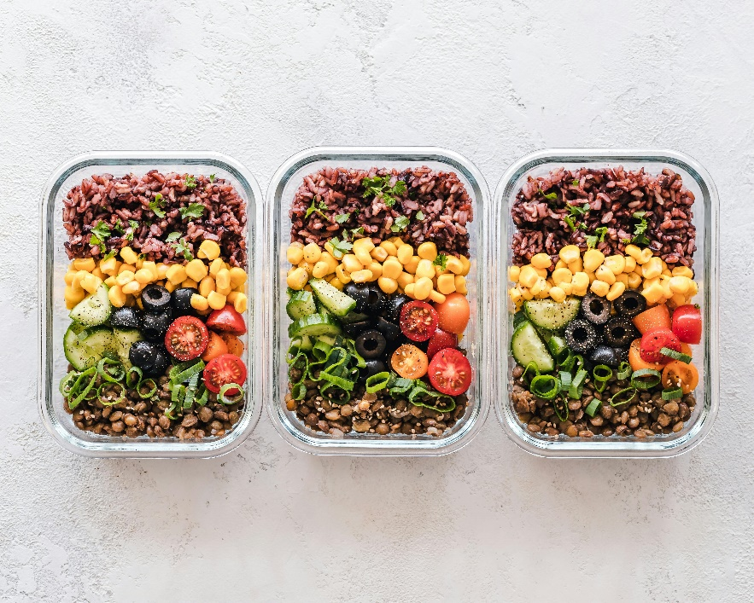You may have heard of the gut microbiome – it’s the community of microbes (example: bacteria) that live in your colon (or gut) that influences your health.

It’s an exciting area of nutrition research because what you eat, and drink can affect the health of your gut and the microbiome. This can affect your risk of chronic diseases like obesity, heart disease, and even certain cancers.

There are many foods that support a healthy gut microbiome which is linked to better overall mental and physical health.

## Whole plant foods

It’s recommended that whole plant foods make up the majority of what you eat. Whole plant foods are vegetables, fruits, whole grains, beans, legumes and nuts that have undergone limited processing. These foods have fibres that feed your gut microbes. For example, whole grains have benefits for metabolism and immunity. Gut microbes feast on parts of the bran layer in whole grains, which has an anti-inflammatory effect. This is important as many chronic diseases are linked to inflammation.

Having a variety of whole plant foods has been shown to help improve feeling of fullness and can help your body to be more sensitive to the insulin, which regulates blood sugar in your body. Choose a variety of plant foods.

As many Canadians struggle with getting enough whole grains, where possible look for opportunities to replace refined grains with whole grain options.

## Protein foods

The protein foods to support gut health are plant-based protein foods and fatty fish. Examples of plant-based protein foods are kidney beans, chickpeas and lentils, nuts like walnuts or almonds and fatty fish like Arctic char, mackerel, herring, salmon, sardines and trout.

Beans and nuts contain fibre, and phytochemicals (plant chemicals) which can help to increase the helpful gut microbes. Fatty fish has omega-3 fatty acids which help lower inflammation.

## Low fat and fermented dairy products

Fermented dairy foods that have live bacteria (like kefir and yogurt) can increase the good bacteria in the gut microbiome.

Look for milk, yogurt, and kefir with little or no added sugar and lower milk fat (M.F.). Lower fat dairy (2% M.F. or less) is recommended over higher fat dairy foods like cheese because they are lower in saturated fat.

Saturated fat is linked to inflammation.

## What to limit or avoid

**Red Meat:** Small amounts of lean red meat can be in included in a healthy eating pattern, as red meat has many nutrients including protein. It is recommended to be included in smaller amounts because it can contribute to inflammation.

**Processed meat:** Avoid or minimize them because the curing agents in processed meats contribute to cancer forming compounds when they are digested by gut microbes.

## Try mediterranean style eating!

The Mediterranean style of eating has been shown to help support a healthy gut microbiome. It includes lots of vegetables, fruits, beans, peas, lentils, fish, nuts, and olive oil. There is some research that it can help support brain function and it can also reduce inflammation as well as frailty in older adults.

If you are looking for practical ways to eat in a way to support a healthy gut microbiome, visit ahs.ca/nutritionhandouts and search for Mediterranean Style of Eating.

v

## Wellness Articles

Alberta Health Services encourages all Albertans to live a healthy life. These weekly Wellness Articles are created by a team of healthcare professionals from AHS in collaboration with   
provincial healthcare experts in Alberta and content from myhealth.alberta.ca.   
Our experts ensure this information is factual, current, and written for Albertans.

From stress-relief strategies to finding balance within your life, these Wellness Articles cover a   
variety of different topics designed to inspire and educate Albertans on creating a positive and   
healthy lifestyle.

We welcome and encourage weekly newspapers, community newsletters and other publications   
to reproduce this information free of charge. Please credit Alberta Health Services or the identified   
content provider.

If you would like to be added to the distribution list for these articles, please email: **rebecca.johnson2@ahs.ca**. You will receive a monthly email containing articles for the   
upcoming four weeks.