# Recognizing eating disorders

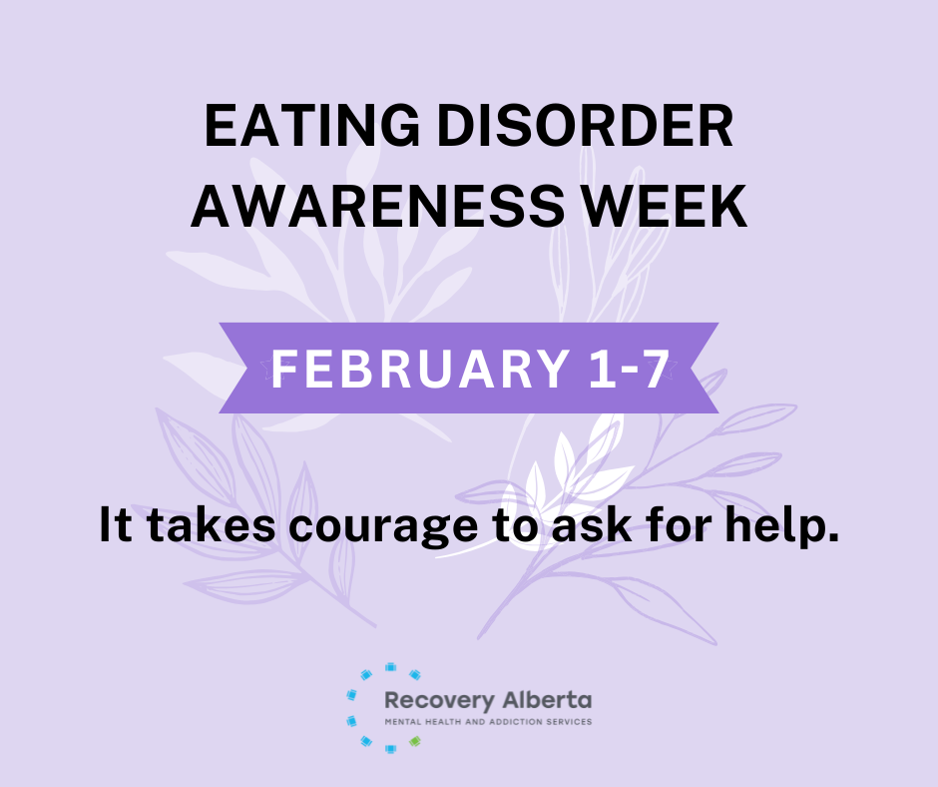The National Eating Disorder Information Centre recognizes Eating Disorder Awareness Week from Feb. 1 to 7, 2025, with a purpose to raise awareness and foster understanding about eating disorders.

Eating disorders (ED) are complex mental illnesses that can affect people physically as well. They affect people of all genders, ages, socioeconomic class, abilities, race, and ethnic backgrounds. They can occur because of many factors like genetics, brain chemistry, one’s environment as well as stressful life events.  This article will explain some common eating disorders and what to do if you suspect that you or someone you know has one.

Types and features of common eating disorders

The purpose of outlining some common features is to highlight the importance of proper diagnosis and treatment.

* ***Anorexia Nervosa:*** People who have anorexia nervosa can weigh less that what is healthy for them. They often think they weigh too much even when they do not weigh enough to stay healthy. People may restrict their intake, engage in excessive exercise and/or engage in purging behaviours such vomiting, misuse of laxatives, diuretics or enemas.
* ***Bulimia Nervosa:*** this is eating large amounts of food within a specified time, feeling out of control during eating, and compensatory behaviours to prevent weight gain (like vomiting or laxatives). Bulimia can occur for anyone, regardless of what they weigh.
* ***Binge eating disorder*** means eating large amounts of food, feeling out of control and can include eating rapidly until uncomfortably full, eating alone, eating when not hungry and negative feelings after binge eating.
* ***Avoidant restrictive food intake disorder (ARFID):*** People with ARFID avoid certain foods due to their sensory characteristics, fear of adverse consequences such as choking or vomiting or general lack of interest in food or eating.

What to do if you think someone has an ED or if you think you may have an ED?

If you think your loved one has an ED, tell them you are worried and let them know you care. It is important to show support. Listen to their feelings and remember the big picture. Eating disorders happen for many different reasons. Many people who have an eating disorder come from families in which other members have eating disorders or have other conditions such as depression. This doesn't mean that a family member caused the disorder. It simply means that these conditions seem more likely to happen in that family.

If you think you have an ED, speak with a primary care provider immediately and explain why you may suspect this. Early intervention is crucial. The primary care provider may ask you to describe any physical or emotional changes you have noticed or experienced that are concerning you.

You can also reach out the ***Recovery Alberta*** ***mental health help line: 1-877-303-2642.*** Remember you are not alone, and help is available. Full recovery from an eating disorder is possible with proper treatment.

For more information about eating disorders and [Eating Disorder Awareness Week](https://nedic.ca/edaw/), visit the Eating Disorder Support Network of Alberta at [edsna.ca](https://edsna.ca/) or National Eating Disorder Information Centre at [nedic.ca](https://nedic.ca/)

v

## Wellness Articles

Alberta Health Services encourages all Albertans to live a healthy life. These weekly Wellness Articles are created by a team of healthcare professionals from AHS in collaboration with provincial healthcare experts in Alberta and content from myhealth.alberta.ca. Our experts ensure this information is factual, current, and written for Albertans.

From stress-relief strategies to finding balance within your life, these Wellness Articles cover a variety of different topics designed to inspire and educate Albertans on creating a positive and healthy lifestyle.

We welcome and encourage weekly newspapers, community newsletters and other publications to reproduce this information free of charge. Please credit Alberta Health Services or the identified content provider.

If you would like to be added to the distribution list for these articles, please email: **rebecca.johnson2@ahs.ca**. You will receive a monthly email containing articles for the   
upcoming four weeks.