# Tips on quitting smoking for good

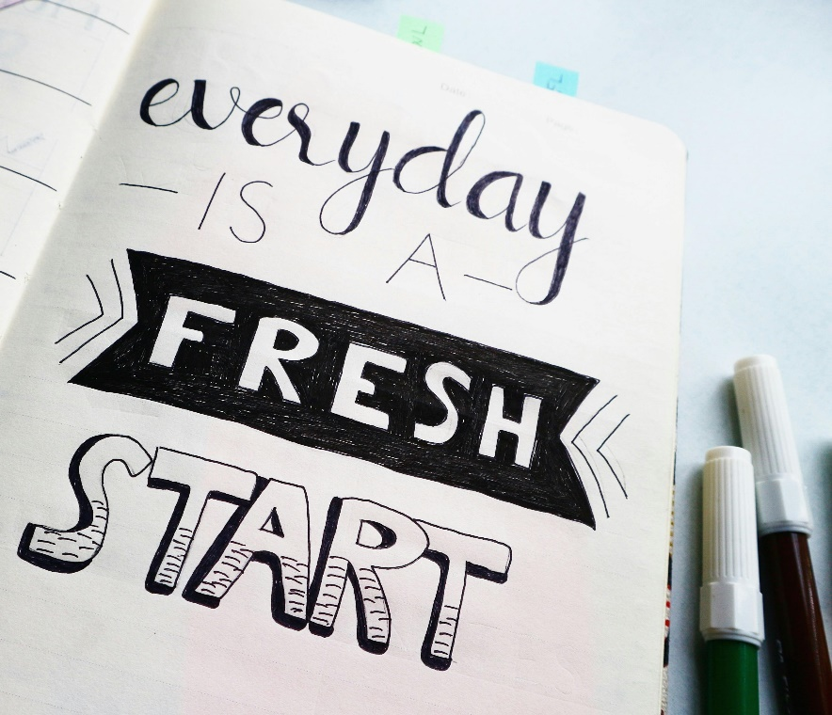Thinking about quitting smoking in 2025? You’re not alone. More than half of adults who smoke cigarettes are seriously thinking about stopping.

Quitting can be hard, but there are things you can do to make it easier. Everyone is different, so it’s important to get the right kind of help for you. Use the tools, programs, and services that make sense for you.

The following tips can help you on your journey.

Know your reasons for quitting smoking

Reflect why you want to quit smoking. Write down or say out loud the reasons that matter most to you. For example:

* *I want to feel better.*
* *I want to save money.*
* *I want to protect my family and friends.*

Taking stock of why you want to quit is a good first step on the path to quitting for good. This activity can help you decide if you’re ready to make a change. It can help you set a goal and stick with it.

Make a plan

When you’re ready, pick a day to quit smoking in the next three weeks. As this date gets closer, pay attention to your urges to smoke. Keep track of the routines, places, and emotions that trigger you. Think about how you’ll handle these cravings and stay in control when you’re quitting.

Planning ahead helps you stay on track when you’re quitting. It sets you up for success in the long run.

Consult the experts

Reach out for advice and support:

* Call 1-866-710-7848 to speak with an [AlbertaQuits counsellor](https://albertaquits.healthiertogether.ca/getting-help/#:~:text=to%20quit%20success.-,Phone%20support,-The%20AlbertaQuits%20helpline). They’ll listen with no judgment and offer you free, confidential advice and helpful tips.
* Ask a [physician](https://albertafindadoctor.ca/), pharmacist or other healthcare provider about medications to reduce cravings, limit withdrawal, and help you feel comfortable when you’re quitting.
* Join a QuitCore program in your local area or online. In six facilitated sessions, you’ll learn skills to quit smoking and connect with other people who are trying to quit. Call the AlbertaQuits helpline at 1-866-710-QUIT (7848) to find a QuitCore group in your local area or online.
* Go to [AlbertaQuits.ca](https://albertaquits.healthiertogether.ca/%22%20/t%20%22_blank) for guidance and tools to build a [quit plan](https://albertaquits.healthiertogether.ca/preparing-to-quit/build-your-quit-plan/%22%20/t%20%22_blank).
* Text 123456 to ABQUITS for free text messages to keep you motivated.

Getting help to quit smoking really works. Research shows that by combining different methods of support, you can double or even triple your odds of success.

Stick with it!

Be mindful that it can take more than one attempt to quit smoking. If you have setbacks, keep trying! Count the days and weeks you were able to go smoke-free as wins and think about what you can learn from them. Reflecting on what worked will help you next time.

Quitting is one of the best things you can do for your health, no matter how old you are or how long you’ve been smoking. Quitting lowers your risk of heart disease, cancer, lung disease, and diabetes. It improves your health in ways you can see and feel. Within 20 minutes of putting out your last cigarette, your blood pressure and heart rate go down with less stress on your heart and blood vessels.

For more information on smoking and your health, go to [MyHealth.Alberta.ca/Tobacco-Smoking-Vaping](https://myhealth.alberta.ca/Tobacco-Smoking-Vaping). For more tips to quit smoking for good, go to [AlbertaQuits.ca](https://albertaquits.healthiertogether.ca/).

v

## Wellness Articles

Alberta Health Services encourages all Albertans to live a healthy life. These weekly Wellness Articles are created by a team of healthcare professionals from AHS in collaboration with provincial healthcare experts in Alberta and content from myhealth.alberta.ca. Our experts ensure this information is factual, current, and written for Albertans.

From stress-relief strategies to finding balance within your life, these Wellness Articles cover a variety of different topics designed to inspire and educate Albertans on creating a positive and healthy lifestyle.

We welcome and encourage weekly newspapers, community newsletters and other publications to reproduce this information free of charge. Please credit Alberta Health Services or the identified content provider.

If you would like to be added to the distribution list for these articles, please email: **rebecca.johnson2@ahs.ca**. You will receive a monthly email containing articles for the   
upcoming four weeks.