# Children and the common cold

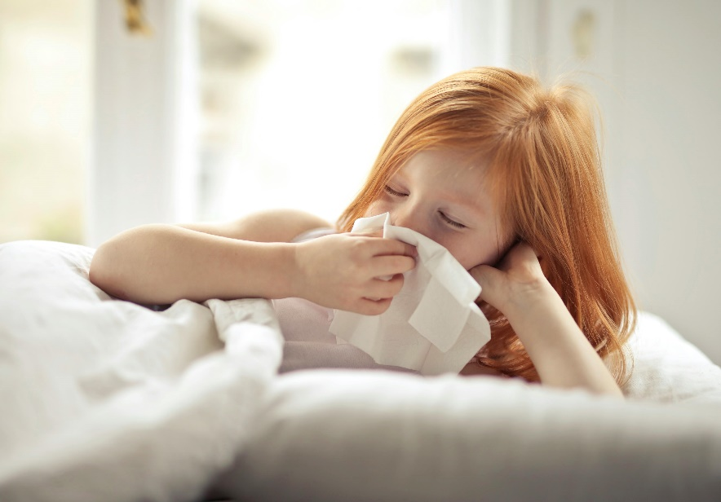The common cold is a viral infection of the nose and throat. It is also known as an upper respiratory tract infection. There are over 200 different viruses that can cause colds. It is normal for children to have an average of six to eight colds per year. Having colds more often is not a sign of a weak immune system. Children develop their immune system by being exposed to many viruses over the years. As children get older, they get sick less often.

The ‘flu’ refers to a specific viral infection caused by the [Influenza virus](https://myhealth.alberta.ca/health/pages/conditions.aspx?Hwid=hw122012). This virus can make people quite sick, especially young children and older adults. People with the flu have more breathing difficulties and high fevers.

Some key facts about the common cold in children

Children with a cold will usually have:

* Stuffy, runny nose
* Sneezing
* Cough
* Fever
* Sore throat
* Decreased appetite

Cold symptoms usually last for three to seven days. Often, symptoms like cough or runny nose, can linger for up to two to three weeks. Fevers usually happen on the first few days your child is sick. Fevers from a cold should get better within three to five days.

Some key points to remember about the common cold in children are:

* 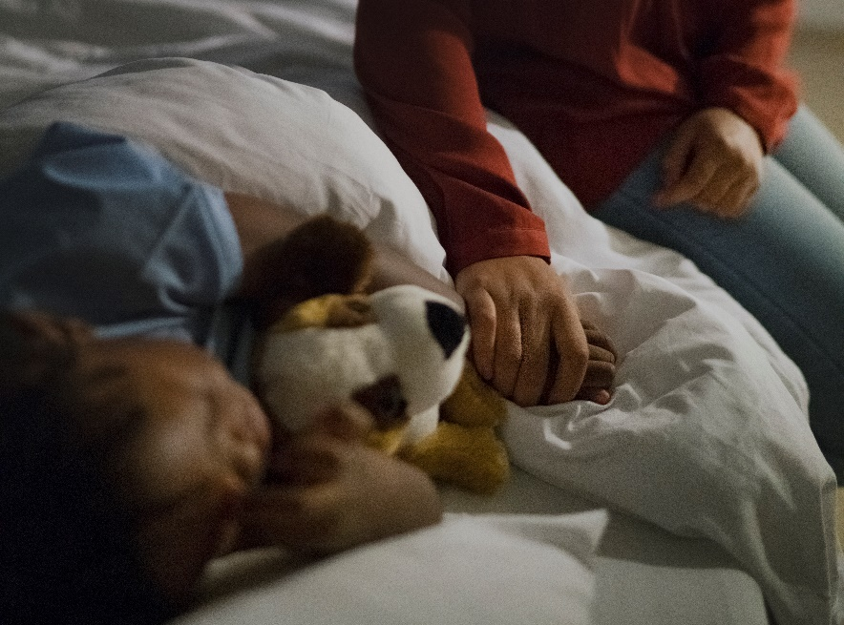Colds are caused by many different viruses and are common in children.
* Colds cause runny nose, sneezing, cough and fevers.
* Colds get better on their own – keep your child comfortable and hydrated.
* If your child has a fever for five days or is not getting better, they should be examined by their doctor.

When should my child see a doctor?

There is no medicine to treat a cold, or make it go away faster. Your child’s body will take care of the virus. The best thing to do is to make your child feel comfortable while they are sick.

While most children will have mild symptoms and get better in a few days, consider having your child seen by a doctor if they are:

* Younger than 3 months
* Having trouble breast or bottle feeding because of their stuffy nose
* Having fevers for more than 5 days
* Having a runny nose that hasn’t improved after 10 days
* Complaining of ear pain or fluid draining from their ear

Call 911 anytime you think your child may need emergency care. Seek immediate medical attention if:

* Your child is having trouble breathing
* Your child’s lips turn blue
* Your child is complaining of neck pain or stiffness
* Your child is lethargic (very sleepy)
* Your child is [dehydrated](https://ahsweb.ca/HEE/HEAL_dehydration_tab_NVD) (dry mouth, no tears, no pee)

**Know your options**

It can be scary when your child is sick. But in most cases, you don’t need to go to the emergency department. If you’re unsure, visit [ahs.ca/options](https://ahsweb.ca/HEE/AHS_Options_page) to learn about the options so you can get the care you need.

**About AHS HEAL**

The Alberta Health Services HEAL (Health Education and Learning) program was created by a team of doctors, nurses, and other clinical staff who work at the Alberta Children’s Hospital and the Stollery Children’s Hospital, to support families and patients with up-to-date and useful information about common childhood health concerns. Learn more at [ahs.ca/heal](https://ahsweb.ca/HEE/HEAL_homepage).

v

## Wellness Articles

Alberta Health Services encourages all Albertans to live a healthy life. These weekly Wellness Articles are created by a team of healthcare professionals from AHS in collaboration with provincial healthcare experts in Alberta and content from myhealth.alberta.ca. Our experts ensure this information is factual, current, and written for Albertans.

From stress-relief strategies to finding balance within your life, these Wellness Articles cover a variety of different topics designed to inspire and educate Albertans on creating a positive and healthy lifestyle.

We welcome and encourage weekly newspapers, community newsletters and other publications to reproduce this information free of charge. Please credit Alberta Health Services or the identified content provider.

If you would like to be added to the distribution list for these articles, please email: **rebecca.johnson2@ahs.ca**. You will receive a monthly email containing articles for the   
upcoming four weeks.