# Can physiotherapy help you?

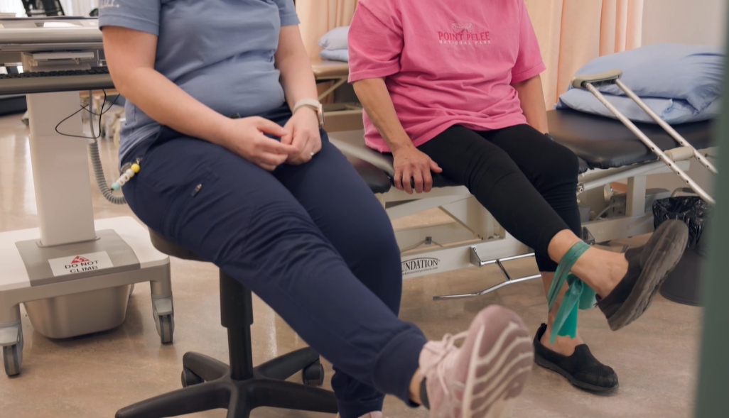Physiotherapy can provide many benefits for anyone of any age. The goal of this treatment is to make daily tasks and activities easier and can help with recovery after some surgeries. Your healthcare provider may suggest physio therapy for injuries or long-term health problems such as arthritis or chronic obstructive pulmonary disease (COPD).

Physiotherapy may be used alone or with other treatments. It can help you move better and may relieve pain, along with improving or restoring your physical function and fitness level.

What does a physiotherapist do?

Your physiotherapist will examine you and talk to you about your symptoms and your daily activity. Your therapist will then work with you on a treatment plan. The goals are to help your joints move better and to restore or increase your flexibility, strength, endurance, coordination, and/or balance.

First, your therapist will try to reduce your pain and swelling. Your physiotherapist also may use [manual therapy](https://myhealth.alberta.ca/health/pages/conditions.aspx?hwid=zh1038&lang=en-ca#zh1038-sec), education, and techniques such as heat, cold, water, ultrasound, and electrical stimulation.

Physiotherapy almost always includes exercise. It can include stretching, [core exercises](https://myhealth.alberta.ca/health/pages/conditions.aspx?hwid=zt1319&lang=en-ca#zt1319-sec), weight lifting, and walking. Your physiotherapist may teach you an exercise program so you can do it at home.

Treatment may cause mild soreness or swelling. This is normal, but talk to your physiotherapist if it bothers you.

What should you look for in a physiotherapist?

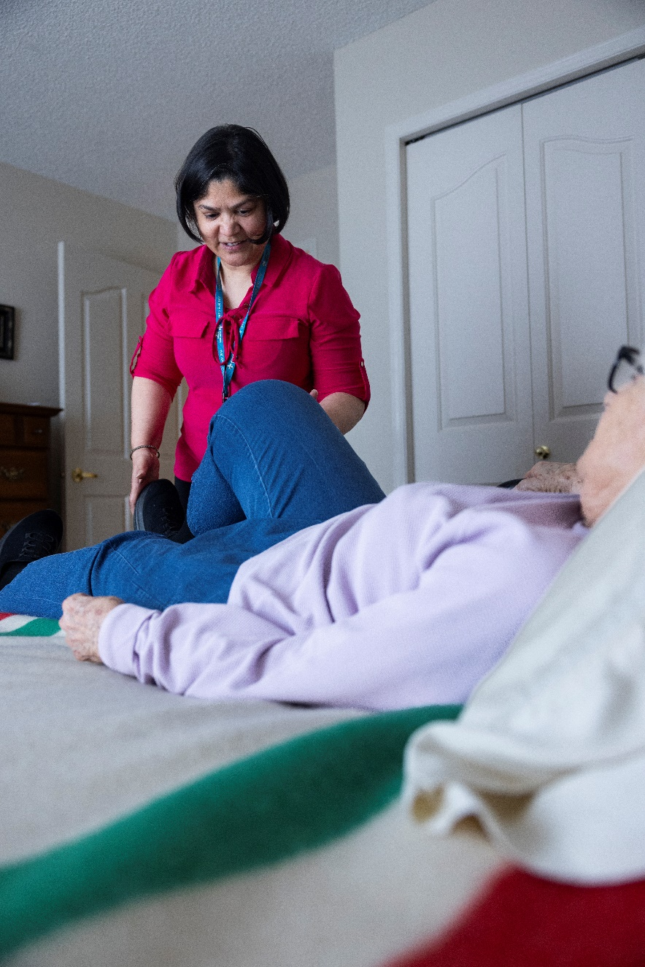You'll want a therapist who has experience with your health problem. Some physiotherapists are certified in areas such as orthopedics, sports, and neurology and may offer more specialized care. Physiotherapists can also specialize in certain types of care, such as:

* Back and neck pain.
* Cardiac rehabilitation (rehab).
* Wound care.
* Cancer-related problems.
* Treatment of children or older adults.

When can physiotherapy help?

**Physiotherapy and recovery from injury**

* Physiotherapy can help you recover from an injury and avoid future injury. Your physiotherapist can help you reduce pain in the soft tissues (muscles, tendons, and ligaments), build muscle strength, and improve flexibility, function, and [range of motion](https://myhealth.alberta.ca/health/pages/conditions.aspx?hwid=str2150&lang=en-ca#str2150-sec). They can also evaluate how you do an activity and make suggestions for doing the activity in a way that is less likely to result in an injury.

**Physiotherapy and chronic health conditions**

* Physiotherapy can help you live more easily with chronic or ongoing health conditions such as [spinal stenosis](https://myhealth.alberta.ca/health/pages/conditions.aspx?hwid=sts15048&lang=en-ca#sts15048-sec), [arthritis](https://myhealth.alberta.ca/health/pages/conditions.aspx?hwid=sta123319&lang=en-ca#sta123319-sec), and [Parkinson's disease](https://myhealth.alberta.ca/health/pages/conditions.aspx?hwid=stp1229&lang=en-ca#stp1229-sec). Your physiotherapist will work with you to establish your goals. Then they will create a program of educational, range-of-motion, strengthening, and endurance activities to meet your needs.

**Physiotherapy and health conditions requiring a rehabilitation team approach**

* Some conditions involve several body systems and can lead to significant disability. These conditions—such as [stroke](https://myhealth.alberta.ca/health/pages/conditions.aspx?hwid=sts15140&lang=en-ca#sts15140-sec), [spinal cord injury](https://myhealth.alberta.ca/health/pages/conditions.aspx?hwid=ug2604&lang=en-ca#ug2604-sec), and major cardiopulmonary (heart and lung) problems—are usually addressed by a team of health professionals through programs such as cardiac rehab and stroke rehab. The team can include doctors; nurses; physiotherapists, occupational therapists, and speech therapists; psychologists; and social workers, among others.
* Physiotherapists are a critical part of this team. They address the issues of range of motion, strength, endurance, mobility (walking, going up and down stairs, getting in and out of a bed or chair), and safety. The physiotherapist may also get you the equipment you need, such as a walker or wheelchair, and make sure you can use the equipment appropriately.

**Physiotherapy and significant health conditions of childhood**

* Physiotherapists also work with children who have major injuries or health conditions, such as [cerebral palsy](https://myhealth.alberta.ca/health/pages/conditions.aspx?hwid=stc123701&lang=en-ca#stc123701-sec). They address the usual issues of range of motion, strength, endurance, and mobility. Also, the therapist considers the child's special growth and developmental needs.
* Treatment is often provided in the school or in a facility just for children. The way physiotherapy and other services are delivered in the schools varies among the provinces. Talk to your child's doctor, school, or your local health unit if you think your child may qualify for evaluation or treatment services.

v

## Wellness Articles

Alberta Health Services encourages all Albertans to live a healthy life. These weekly Wellness Articles are created by a team of healthcare professionals from AHS in collaboration with provincial healthcare experts in Alberta and content from myhealth.alberta.ca. Our experts ensure this information is factual, current, and written for Albertans.

From stress-relief strategies to finding balance within your life, these Wellness Articles cover a variety of different topics designed to inspire and educate Albertans on creating a positive and healthy lifestyle.

We welcome and encourage weekly newspapers, community newsletters and other publications to reproduce this information free of charge. Please credit Alberta Health Services or the identified content provider.

If you would like to be added to the distribution list for these articles, please email: **rebecca.johnson2@ahs.ca**. You will receive a monthly email containing articles for the   
upcoming four weeks.