# Colorectal cancer screening saves lives

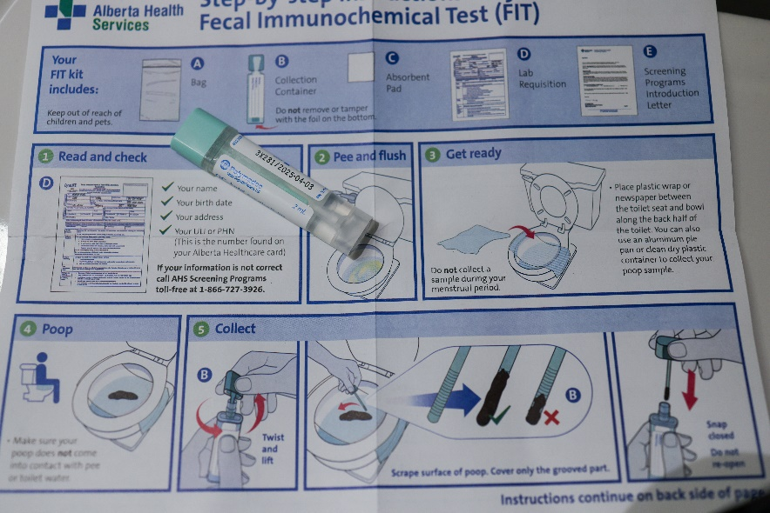Colorectal cancer is one of the most common causes of cancer deaths in Alberta, often affecting people over 50 with no family history of the disease.

Colorectal cancer develops in the colon (large intestine) or rectum and can begin as growths called “polyps” on the inner wall of the colon or rectum. Not all polyps turn into cancer, but some types can with time. Early-stage colorectal cancer and polyps can exist for years, without symptoms.

March is Colorectal Cancer Awareness Month — a vital reminder to get screened regularly, especially if you are between 50 and 74-years-old. Screening looks for early signs of cancer in people who feel well and have no symptoms. With regular screening, colorectal cancer can be found early, and many types of polyps can be removed before they turn into cancer.

Screening tests for colorectal cancer

The two main screening tests for colorectal cancer are Fecal Immunochemical Test (FIT) and colonoscopy. You and your healthcare provider can discuss which test is right for you.

**Fecal Immunochemical Test (FIT)** – FIT is the recommended screening test for people at average risk of getting colorectal cancer. Most people are at average risk. Average risk means those with no symptoms and no personal or family history of colorectal cancer.

FIT is an easy, at-home test that checks for hidden blood in your stool. You collect a small stool sample and take your completed FIT to the lab for testing. You should plan to do the FIT every year starting at age 50.

There are two easy ways to get your free FIT:

* Talk to your doctor about colorectal cancer screening. They’ll give you a lab requisition form. Take this form to the lab to pick up your FIT.
* 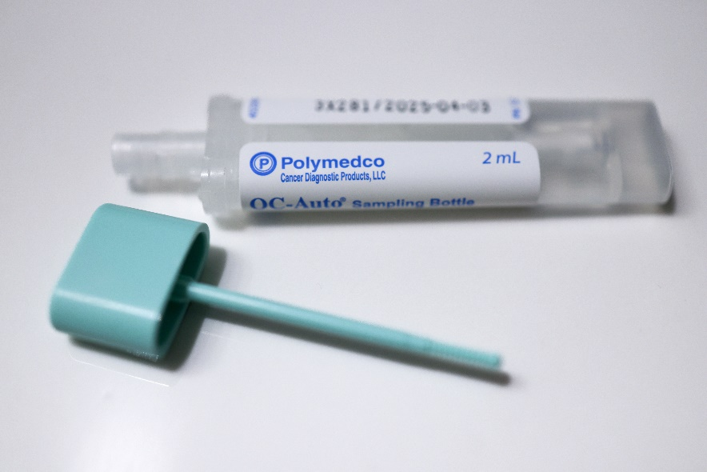Order online at screeningforlife.ca or call AHS Screening Programs toll-free at 1-866-727-3926. We’ll mail you a FIT.

If your FIT result is normal, it means that no blood was found in your stool sample. You should continue to screen with FIT regularly. If your FIT result is abnormal, it means that blood was found in your stool sample. This can happen for different reasons. While most people with an abnormal result do not have cancer, your doctor or healthcare provider may recommend a colonoscopy to find the cause of the bleeding.

 For every 100 colonoscopies after an abnormal FIT, two to three cases of colorectal cancer are detected. Early detection leads to a **90% treatment success rate**, making regular screening essential.

**Colonoscopy** – Colonoscopy is the recommended test for people at an increased risk of getting colorectal cancer. You may be at increased risk if you or someone in your family such as a parent, sibling, or child had colorectal cancer in the past. Colonoscopy is also the recommended follow-up test after an abnormal FIT result.

 A colonoscopy lets the doctor see the inside of your colon. This test is done using a colonoscope, which is a long, thin, flexible tube with a light and camera on the end.

Colorectal cancer signs and symptoms

Never ignore new symptoms including blood in your stool, a change in your bowel habits, pain in your belly, or unexplained weight loss. See your doctor or healthcare provider if you develop these or any other symptoms you’re worried about. These symptoms may not be caused by cancer, but speaking to your healthcare provider can help you know for sure.

The importance of screening

Screening can help save lives. But it can be hard to start a conversation with those you care about who may have put off screening. Here are some tips for talking to someone you know about colorectal cancer screening:

* **Be encouraging.** Remind them that you care and want them to be around for a long time.
* **Focus on the lifesaving benefits of screening.**
* **Break down barriers.** Let them know FIT is **free** and can be done in the privacy of their own home. Share information on how they can **order a FIT online** at screeningforlife.ca
* **Give them time.** Let them think about it and decide for themselves if screening is right for them. If they have questions, encourage them to talk to their healthcare provider or call AHS Screening Programs at 1-866-727-3926.

If you need help finding a family doctor:

* Visit [Alberta Find a Doctor](https://albertafindadoctor.ca/)
* Call [Health Link at 811](https://www.albertahealthservices.ca/info/page12630.aspx)

[Click here to learn more about colorectal cancer](https://screeningforlife.ca/colorectal/)

v

## Wellness Articles

Alberta Health Services encourages all Albertans to live a healthy life. These weekly Wellness Articles are created by a team of healthcare professionals from AHS in collaboration with provincial healthcare experts in Alberta and content from myhealth.alberta.ca. Our experts ensure this information is factual, current, and written for Albertans.

From stress-relief strategies to finding balance within your life, these Wellness Articles cover a variety of different topics designed to inspire and educate Albertans on creating a positive and healthy lifestyle.

We welcome and encourage weekly newspapers, community newsletters and other publications to reproduce this information free of charge. Please credit Alberta Health Services or the identified content provider.

If you would like to be added to the distribution list for these articles, please email: **rebecca.johnson2@ahs.ca**. You will receive a monthly email containing articles for the   
upcoming four weeks.