# Overcoming the barriers of fruit and vegetable intake

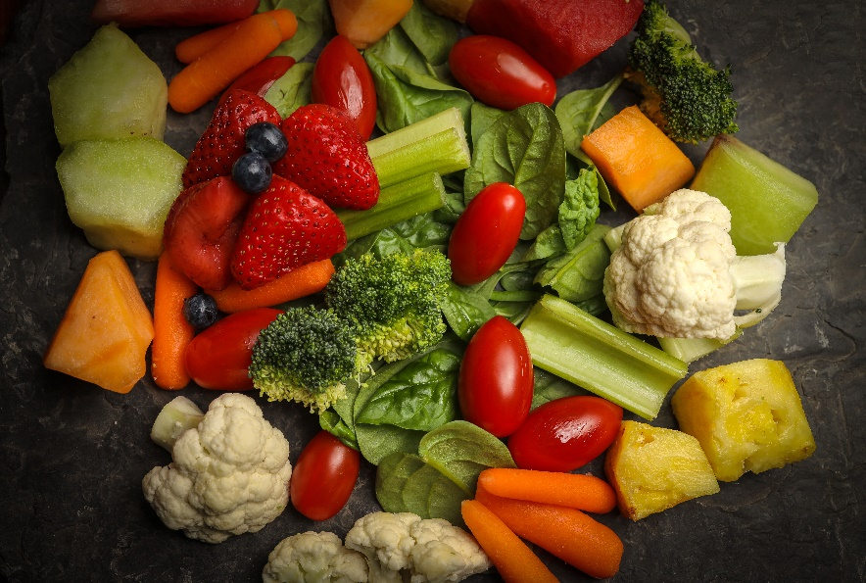Did you know that since 2015, intakes of vegetables and fruit by Canadians have been steadily decreasing? Only 16 per cent of Albertan men consume vegetables and fruit five times or more per day.

Most people know that vegetables and fruit are good for their health.

Research has shown that men identified the following barriers to getting enough vegetables and fruit daily:  lack of time, taste and cost. Read more to find out about these obstacles and tips on how to incorporate more fruit and vegetables in your daily life.

Lack of time

Having a busy schedule, whether it is due to work, family, or other daily activities, may make it difficult to plan, shop for, and prepare healthy meals and snacks. The following tips provide ways to add vegetables and fruits into your daily diet, without making meal preparation too overwhelming.

* ***Plan ahead:***
  + Look at your schedule at the beginning of the week and brainstorm meal and snack ideas for the week.
  + Choose vegetables and fruits that can be used for multiple meals in that same week to reduce waste. Try filling ½ of your plate with vegetables and fruits at every meal.
  + Feeling like you have no time to cook? Try preparing your meals in bulk on your days off for the week ahead. This way, you can come home after a busy day to a completed meal full of vegetables.
* ***Grocery shop with ease:***
* 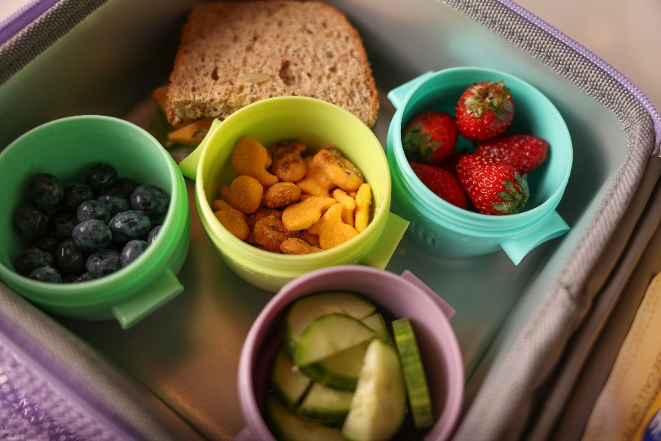Make a grocery list and stick to it. This may reduce food waste and additional grocery trips.
* Buy vegetables, fruits, and other ingredients needed for your meals and snacks ahead of time so you have enough for the week ahead.
* To reduce food preparation time, try pre-cut or pre-washed vegetables such as baby carrots and spinach or frozen mixed vegetables.
* ***Prepare:***
  + Place washed and cut up vegetables in containers to always have options ready to go
  + Add it to your breakfast: berries on cereal/oatmeal, vegetables to omelets, spinach to smoothies.
  + Add it to your lunch or dinner: broccoli to macaroni and cheese, peppers and mushrooms on pizza, extra vegetables in stir-fries.
  + Choose fruits that come in their own “package.” Bananas, oranges and apples are foods that require no cutting or to be put into containers.

Texture and taste

Flavours and textures of some vegetables and fruits may not be appealing to all people. However, with some various preparation and pairings, these suggestions might influence you to retry your least favourite vegetable or fruit:

* **Try new cooking methods and textures**
* Roasted: Roasting is a slow cooking process that uses dry heat (like an oven) at high heat to cook and create browned edges on the food. Try roasting broccoli and topping it with parmesan cheese or thinly slicing sweet potatoes into fries.
* Pureed: Pureeing changes the textures of solid foods by turning them into a smooth texture with no lumps. Use a blender or food processor to puree berries into a sauce or squash into a soup.
* Steamed: Steaming uses indirect heat from hot steam to cook food. Try steaming frozen or fresh corn and add it into a dish.
* Grilled: Grilling is a quick cooking method that uses direct heat at a high temperature. Try placing mushrooms and peppers on a skewer and placing them on your BBQ or even place them directly onto the grill.
* Sautéed: Sautéing uses a hot pan with a small amount of fat over high heat while constantly stirring the food. Use chopped onions, broccoli and carrots with some olive oil to add into your next meal.
* **Add some flavour**
  + Drizzle olive oil or lemon juice, and add herbs or garlic to vegetables
* **Pair with foods you enjoy**
  + Add bananas, apples, or berries into pancakes
  + Add carrots, zucchini, or apple into muffins and loaves
  + Add mushrooms or peppers into your favourite omelets
  + Add tomato and lettuce to a burger

Cost

With grocery prices rising, it can be difficult to incorporate vegetables and fruit into your diet. Check what you have at home in your pantry, fridge, and freezer before going out to buy more vegetables and fruit. See if you can use what you already have.

Plan your shopping trips and compare prices with different grocery stores to find the cheapest products. Some stores will even match a lower price product found at a competitor's store. Compare brand names, as some popular brands may be more expensive than a generic brand. Look for grocery stores with discount days, where you can save money off your total grocery bill. Fresh, frozen, and canned vegetables and fruits are equally healthy options. Research fresh produce in season or choose frozen and canned options for lower prices of your favourite vegetables and fruits. Choose items with close best before dates if you can use it within the date, as they may price it lower.

Store food properly. Storing vegetables and fruit properly will reduce waste, prevent extra grocery store trips, and save you money. Some vegetables and fruit should be stored at room temperature, while others need to be refrigerated. Freezing produce can allow them to last longer and to be used at a later time. Visit Canada.ca/FoodGuide and search “Storing Vegetables and Fruits” to find out more information.

Find more resources on healthy eating including meal planning, recipes, and grocery shopping tips at HealthyEatingStartsHere.ca.

Find more tips on incorporating vegetables and fruits into your diet at Canada.ca/FoodGuide.

v

## Wellness Articles

Alberta Health Services encourages all Albertans to live a healthy life. These weekly Wellness Articles are created by a team of healthcare professionals from AHS in collaboration with provincial healthcare experts in Alberta and content from myhealth.alberta.ca. Our experts ensure this information is factual, current, and written for Albertans.

From stress-relief strategies to finding balance within your life, these Wellness Articles cover a variety of different topics designed to inspire and educate Albertans on creating a positive and healthy lifestyle.

We welcome and encourage weekly newspapers, community newsletters and other publications to reproduce this information free of charge. Please credit Alberta Health Services or the identified content provider.

If you would like to be added to the distribution list for these articles, please email: **rebecca.johnson2@ahs.ca**. You will receive a monthly email containing articles for the   
upcoming four weeks.