# Promoting mental health in children

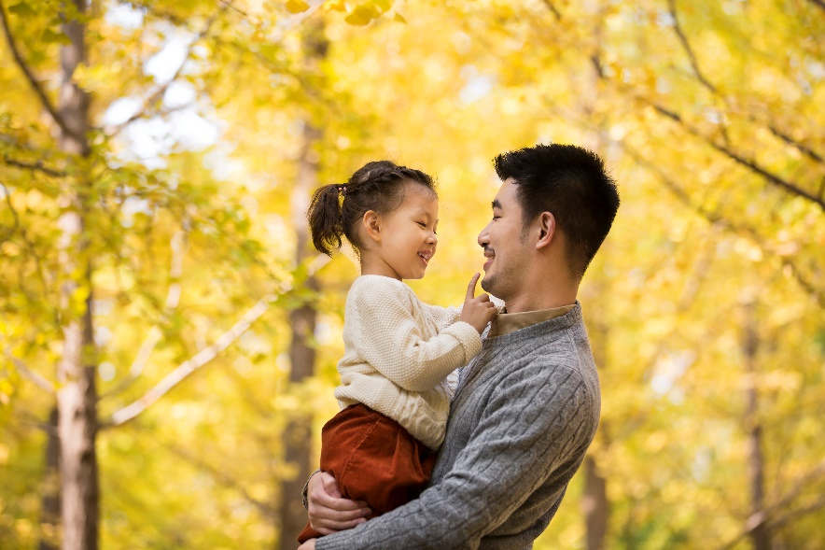​​​​​​​Supporting your child’s mental health is as important as good nutrition, sleep, and physical activity. Having good mental health allows your child to think clearly, develop socially, and learn new skills.

These tips can help your child develop confidence, self-esteem, and compassion for others.

Apologize when you’re wrong

When you make a mistake, apologize to your child. Saying you’re sorry isn’t enough. Sincere and simple apologies build trust and show respect for your child’s feelings. Admit you were wrong, explain how it affected your child, and show that you’re sorry. For example:

* "I shouldn’t have said your idea was stupid. I know that hurt your feelings and embarrassed you. I’m ashamed I spoke to you that way. I’m sorry. I won’t do it again."

Avoid explanations that sound like excuses or blame your child. For example:

* "I’m sorry I got mad but you were really getting on my nerves."

Give your child choices and respect their wishes

When you can, give your child the chance to make their own choices that are meaningful to them and acceptable for you. If your child has a chance to make choices it helps them:

* feel a sense of control
* develop self-esteem
* learn how to solve problems
* take responsibility for their choices

Ask questions that help your child solve problems on their own

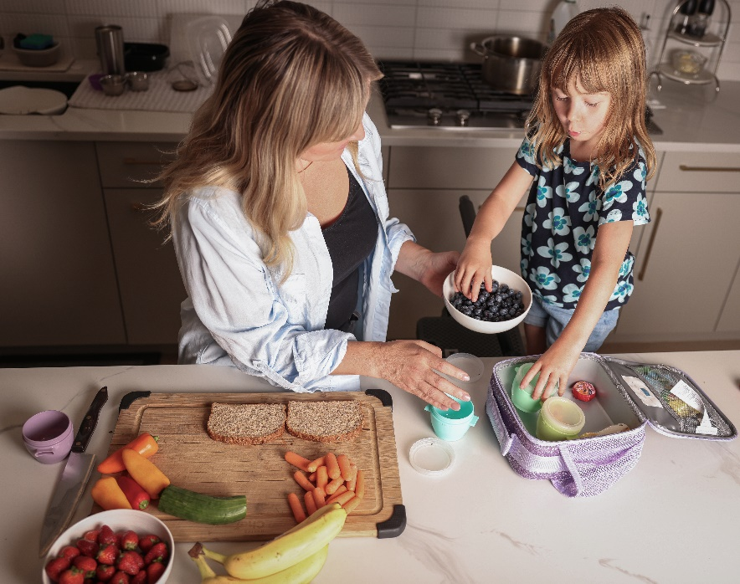It’s tempting to take over and give a solution when you hear that your child has a problem. But this doesn't help your child find solutions on their own. Try asking questions that will help them solve problems. For example:

* "What do you think you can do about this?"
* "If you choose to do this, what do you think might happen?"

Encourage sharing and helping by giving your child tasks that are appropriate for their age, such as feeding the family pet, getting the mail, helping with making their lunch, or making their bed. Together, you and your child can volunteer or help a neighbour. This builds self-confidence and compassion. It also teaches your child that what they do can make a difference in the lives of others.

Read books and stories together

Even if your child can already read, they’ll still love reading with you. Take turns reading out loud with your child. Reading aloud is a way to share something enjoyable and learn about other people. For example, stories can show us how people deal with common issues like making or losing friends, handling conflicts, or dealing with difficult emotions. Talk to your child about what they like to read. Ask your child’s teacher or a librarian to recommend stories on themes that interest you and your child. ​

Be a role model

​​​​​​Your child will learn by watching and doing what you do. They learn how to look after themselves, build relationships, solve problems, handle emotions (feelings), and care for others by seeing how you respond.

Your emotions affect what you do and say. They affect your child too. For example, anger is a common human emotion. You may feel angry sometimes when your child whines, talks rudely, or doesn’t do what you ask. If you react to anger by yelling, using harsh words, or calling them names, it affects your child. They’ll also learn to do the same when they’re angry.

What you do and say when you’re angry is important to your relationship and to how your child learns to express their anger. When you practice managing your feelings in healthy ways, your child learns these skills too.

v

## Wellness Articles

Alberta Health Services encourages all Albertans to live a healthy life. These weekly Wellness Articles are created by a team of healthcare professionals from AHS in collaboration with provincial healthcare experts in Alberta and content from myhealth.alberta.ca. Our experts ensure this information is factual, current, and written for Albertans.

From stress-relief strategies to finding balance within your life, these Wellness Articles cover a variety of different topics designed to inspire and educate Albertans on creating a positive and healthy lifestyle.

We welcome and encourage weekly newspapers, community newsletters and other publications to reproduce this information free of charge. Please credit Alberta Health Services or the identified content provider.

If you would like to be added to the distribution list for these articles, please email: **rebecca.johnson2@ahs.ca**. You will receive a monthly email containing articles for the   
upcoming four weeks.