# What are imaging tests?

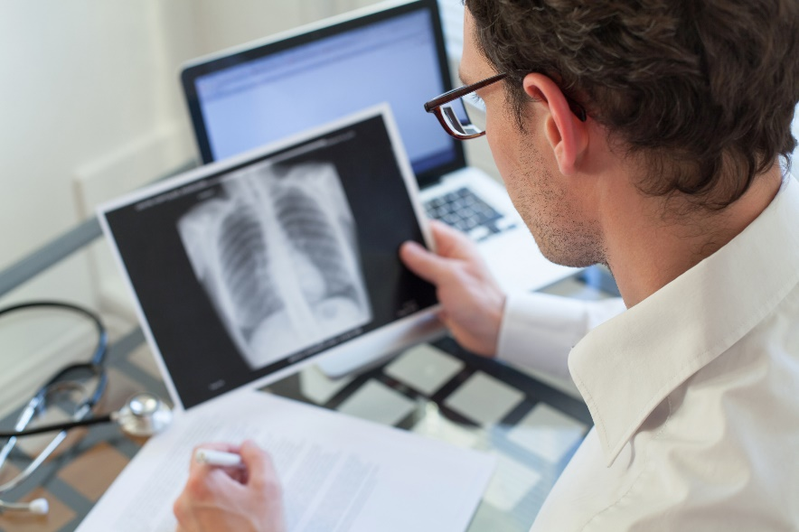Imaging tests (also called diagnostic imaging tests) let your healthcare team look for clues inside your body. They can help your doctor find out what’s making you feel unwell and find disease early, even when you don’t feel sick. Your healthcare team uses the results of your imaging tests along with other information to find out what’s causing a health problem (called a diagnosis).

Each type of imaging test shows different details and information about the organs and structures in your body. Your healthcare team chooses which imaging test you need based on your symptoms and the part of your body they want to look at. They’ll often send you for more than one type of imaging test to help them understand the problem or cause of your symptoms.

How imaging tests are done

Imaging tests use different types of machines and procedures to take pictures of the inside of your body. These tests show what your organs and structures look like. And some even show how well they’re working. The information from imaging tests helps you and your healthcare team decide the care and treatment that’s best for you.

Many imaging tests are quick, painless, and easy. Some tests are done while you’re lying inside of a machine. Imaging tests can be very short and others take longer to do.

Some imaging tests use a small amount of radiation and others don’t. Most imaging tests are non-invasive, but some are minimally invasive. Your healthcare team will let you know if your test is non-invasive or minimally invasive. Non-invasive means your healthcare team doesn’t put a tool or device inside your body. Minimally-invasive means your healthcare team passes a tool or device through a small cut in your skin during a test or procedure.

Your healthcare provider will give you instructions for how to prepare for your test. Be sure to follow the instructions carefully.

Imaging tests and your health and safety

Some imaging tests use radiation (a wave of energy), and contrast dye, Image-guided test may also use sedation or anesthesia (medicine to numb an area or make you sleepy and comfortable). When you or your child has one of these tests, you might have questions about health and safety.

Your imaging healthcare team will watch you closely to keep you safe. Ask them any questions you have about health and safety. You can also talk to your healthcare provider to learn more about safety and imaging tests.

The healthcare team

When you have an imaging test, you’ll meet a technologist. Technologists are healthcare professionals who work in a diagnostic imaging department. They’re often the ones who use the equipment and machines to do your test. They make sure the pictures show the right amount of detail and information to help the radiologist make a diagnosis.

Radiologists are doctors who work in a diagnostic imaging department.

* Diagnostic radiologists diagnose diseases. They look at your test results and let other doctors know what they find.
* Interventional radiologists treat diseases with therapeutic imaging procedures. They use imaging tests to guide needles, probes, or other tools inside the body.

Diagnostic imaging departments may also include nurses. Nurses help prepare you for your procedure, support the radiologist, and keep you as comfortable as possible during the procedure. They’re also the healthcare team members who watch you as you recover after any type of imaging test or procedure.

Find out more about [medical specialists](https://myhealth.alberta.ca/health/pages/conditions.aspx?Hwid=specl) on healthcare teams.​

v

## Wellness Articles

Alberta Health Services encourages all Albertans to live a healthy life. These weekly Wellness Articles are created by a team of healthcare professionals from AHS in collaboration with provincial healthcare experts in Alberta and content from myhealth.alberta.ca. Our experts ensure this information is factual, current, and written for Albertans.

From stress-relief strategies to finding balance within your life, these Wellness Articles cover a variety of different topics designed to inspire and educate Albertans on creating a positive and healthy lifestyle.

We welcome and encourage weekly newspapers, community newsletters and other publications to reproduce this information free of charge. Please credit Alberta Health Services or the identified content provider.

If you would like to be added to the distribution list for these articles, please email: **rebecca.johnson2@ahs.ca**. You will receive a monthly email containing articles for the   
upcoming four weeks.