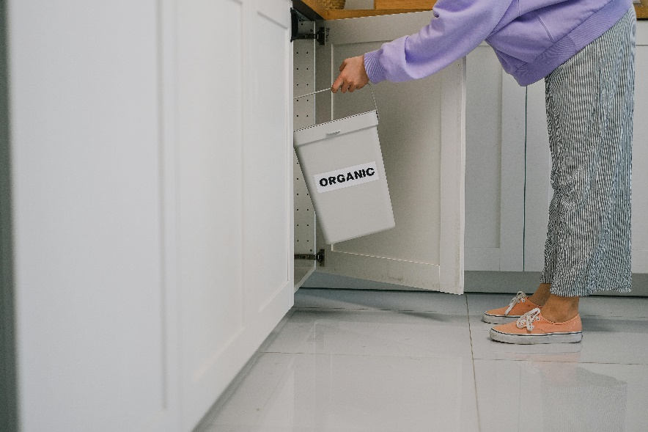Reducing household food waste: planning, shopping and storage

Food waste is food that was grown or harvested, but never eaten. Some food waste at home can’t be avoided, like egg shells, bones, tea bags or coffee grounds, but some food waste can. Avoidable food waste is food that is thrown out because we don’t store it properly, buy too much, or cook too much. A 2022 study showed that 63% of food Canadians throw away could have been eaten. While all types of foods are wasted, the top foods that are thrown away are: vegetables and fruits, leftovers, and bread.

This article includes tips and resources to reduce your food waste at home.

Planning your meals

Planning meals a few days or a week ahead of time may prevent you from buying too much food. Consider what food items you already have. Check your fridge and cupboards carefully to see how much is left in containers or packages. Checking best before dates is helpful so you can used up food while it’s at its freshest. Note that ‘best before’ dates are not the same as expiration dates. Expiration dates are about food safety, whereas ‘best before’ dates are about freshness. So just because a food is past its ‘best before’ date doesn’t mean it needs to be tossed. Then think about some meals that you like or can easily make with items you already have. Then create a list on paper or your phone of items you do not have.

Grocery shopping

When buying fresh, consider what options are best for your family, for example, pre-washed and pre-cut fruits, vegetables and salads can be convenient, but are more expensive. However, if this means you are more likely to eat them instead of throwing out unprepared produce, then this may be an option for you. It can also be helpful to pre-wash and cut your produce for easy access during the week, so you are more likely to eat it and less likely to have waste.

Frozen and canned options are also time-savers as the preparation has already been done for you. They last a lot longer than fresh, so are less likely to go bad before you can use them up. Buying frozen or canned produce offers year-round variety that otherwise might not be available. Try adding frozen or canned vegetables into pasta sauce, casseroles, soups or stir-fry. Frozen or canned fruit can be added to yogurt, cereal, baking or smoothies.

Storing foods

Consider the order that you use some foods as some foods can keep longer in the fridge than others. Most fresh vegetables and fruits will stay fresh longer if they are unrinsed. Consider washing produce before preparing, freezing or eating it. Some produce give off a gas (ethylene) that speeds up ripening- apples, bananas, kiwis, tomatoes, avocados. Keep these vegetables and fruits in a loosely tied bag away from already ripe produce. Some produce will also stay fresh longer than others so consider using produce like kale, chard, carrots and cabbage later in the week.

Since bread and baked goods are among the top foods that are thrown away, store bread and buns in a cool, dark and dry place in the original packing. Or consider freezing if you don’t think you will be able to use up the bread by the best before date. Storing bread in the fridge may make it go stale more quickly.

If you have leftovers, it’s important to store them properly. Wrap leftovers or place them in a covered container. Place them in a refrigerator within two hours of preparing or cooking. Consider labelling them with a date and remember to use the oldest ones first. Leftovers like soup can be safely eaten within 2-3 days after cooking, while other cooked dishes containing eggs, meat and vegetables or cooked fish, poultry can be safely eating with 3-4 days of being stored at the correct temperature in the fridge. Leftovers can be frozen for longer.

Making some or all of these choices when shopping or storing food can play a part in reducing your food waste at home.

For more helpful tips on food storage and safety visit Canada.ca and search: “Storing Vegetables and Fruits” and “Food Safety”

For more ideas to reduce food waste visit: ahs.ca/nutritionhandouts and search “Reduce Food Waste.”

v

## Wellness Articles

Alberta Health Services encourages all Albertans to live a healthy life. These weekly Wellness Articles are created by a team of healthcare professionals from AHS in collaboration with provincial healthcare experts in Alberta and content from myhealth.alberta.ca. Our experts ensure this information is factual, current, and written for Albertans.

From stress-relief strategies to finding balance within your life, these Wellness Articles cover a variety of different topics designed to inspire and educate Albertans on creating a positive and healthy lifestyle.

We welcome and encourage weekly newspapers, community newsletters and other publications to reproduce this information free of charge. Please credit Alberta Health Services or the identified content provider.