Building Your Emergency Food Kit

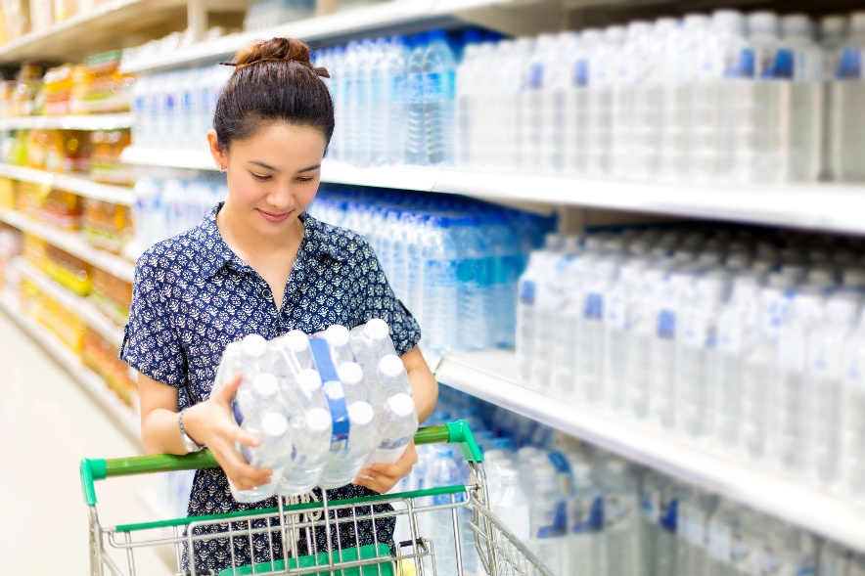Emergencies often happen without warning. They may be natural disasters like floods, wildfires, or severe storms that require evacuation. They could also be events such as extended power outages that require you to shelter in place for some time. In both cases, access to food and water may be limited so it’s a good idea to have an emergency food kit ready. Your kit should contain a collection of non-perishable, ready-to-eat food items stored for use during emergencies when access to supplies may be disrupted.

This article will provide information on what emergency food kits are, why they are necessary and what to include in your kit.

Why an Emergency Food Kit Matters

During a disaster, you may not be able to shop for food, cook, or access clean water. You may have to evacuate your home with very little notice or be asked to shelter in place. Having an emergency kit is essential. An emergency food kit contains non-perishable foods designed to sustain your family during unexpected situations like natural disasters. Food items can be stored for a long time without refrigeration and are ideal for emergencies. In addition to peace of mind, having an emergency kit ensures you will have enough energy to handle the physical and emotional stress that emergencies often cause.

When assembling an emergency food kit, it’s important to consider both nutrition and practicality. Focus on non-perishable items that are easy to prepare, require minimal cooking, and meet basic needs. Your grab and go emergency kit should contain enough food and water for each member of your family for a minimum of 72 hours. If sheltering at home, ensure that you are prepared for a minimum of 14 days.

Items to Include

Choose non-perishable foods using the principles from Canada’s Food Guide and consider what you might have for meals and snacks. Examples include dry cereal with shelf-stable milk and dried fruit or Canned fish, with whole grain crackers and canned vegetables.

Some of these items require minimal heating. If you do not have a camp stove, and fuel as well as pots for an emergency kit, do not choose foods that require some heating.

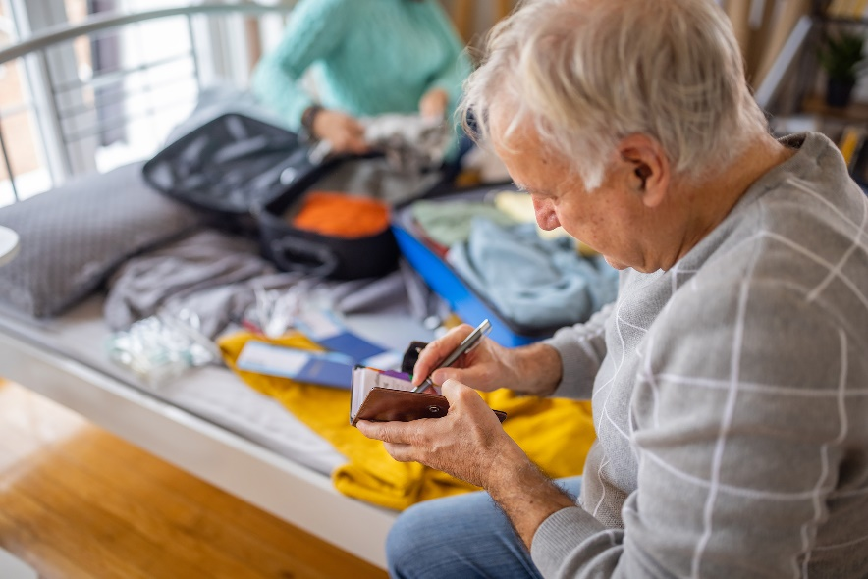**Water:** 4 L per person, per day for drinking and basic hygiene.

**Vegetables and Fruits:** dehydrated potatoes, canned fruits and vegetables, canned vegetable soups, as well as dried fruits.

**Grain foods:** Crackers, cereal, granola bars, and instant oatmeal, rice or pasta. Consider whole grain crackers and cereal for added nutrition.

**Protein foods:** Protein options include canned beans, or canned meat, nuts, seeds, nut butters, and jerky.

**Milks and Plant-based beverages:** Choose ones that are sold at room temperature and in special cartons or in cans. These do not need refrigeration until they are opened.

**Special Diet Foods:** If you have individuals with dietary restrictions, ensure that your kit contains enough specialty foods to meet special dietary requirements to last for the full duration of the emergency.

**Other Foods:** While it’s important to focus on essentials, you may also want to include some foods such as canned pudding, chocolate or packaged snacks, tea or coffee.

**Meal Preparation materials**: Include plates, cutlery, a multipurpose knife, manual can opener and hand sanitizer. If you have a camp stove, store it with your emergency food kit as well as fuel and a pot or pan.

**If you have pets, remember to include their water and food needs.**

Practical Considerations

Store food in a cool, dry place and avoid areas prone to moisture or pests. When packing canned and dried goods, opt for smaller containers that can be consumed in one sitting to prevent spoilage once opened. Check foods every year and rotate out those that are nearing expiry as needed. Some foods may last for several years.

Emergency preparedness is essential for every household, and a well-planned food kit can provide comfort, nutrition, and safety during crises. By incorporating a variety of non-perishable items and water, you can ensure that you and your family remain well-nourished and prepared for any emergency.

Setting aside food for emergencies may not be possible for everyone due to cost. There may be resources in your social network or community to go to in case of emergency. Call, text, or chat with 211 Alberta ([ab.211.ca/](https://ab.211.ca/)) to find out about financial benefits, programs, and services.

v

## Wellness Articles

Alberta Health Services encourages all Albertans to live a healthy life. These weekly Wellness Articles are created by a team of healthcare professionals from AHS in collaboration with provincial healthcare experts in Alberta and content from myhealth.alberta.ca. Our experts ensure this information is factual, current, and written for Albertans.

From stress-relief strategies to finding balance within your life, these Wellness Articles cover a variety of different topics designed to inspire and educate Albertans on creating a positive and healthy lifestyle.

We welcome and encourage weekly newspapers, community newsletters and other publications to reproduce this information free of charge. Please credit Alberta Health Services or the identified content provider.