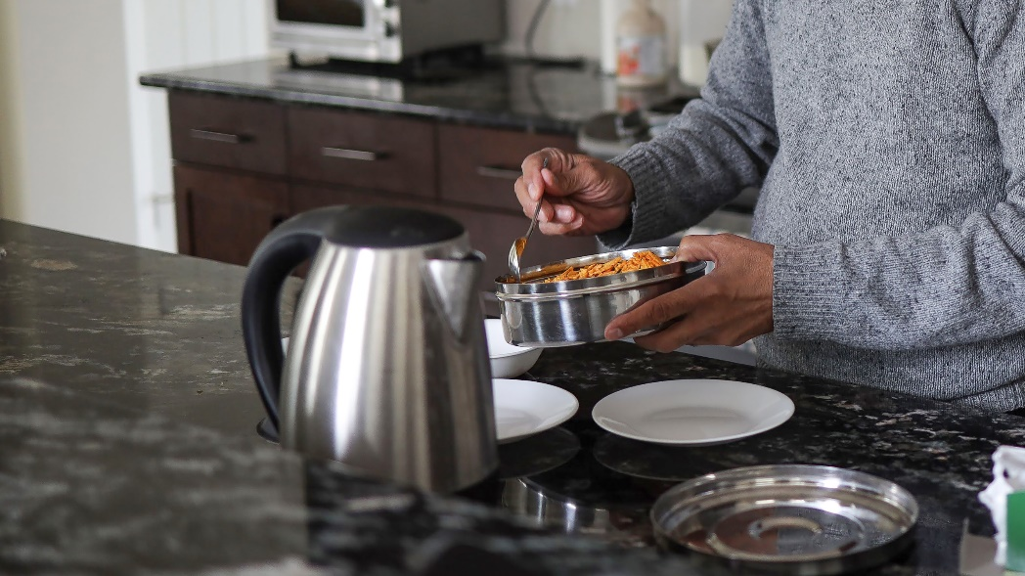Nutrition to Help Manage Blood Pressure

May 17 is World Hypertension Awareness Day, a day to learn about how we can manage blood pressure for better heart health. Hypertension means there is too much pressure in your blood vessels. Over time, this can damage them and can increase your risk of heart attack and stroke.

Managing high blood pressure may include changing what you eat, managing your body weight, being physically active, limiting alcohol, engaging in relaxation practices, reducing or stopping tobacco use, and can include medication. Your healthcare provider can support you.

This article will focus on which food and nutrition choices may help manage your blood pressure. It includes what to eat more of and what to cut back on.

What to consume more of

**Vegetables and Fruits:** Vegetables and fruits are packed with fibre and nutrients that can help lower blood pressure. People who eat many vegetables and fruit are at lower risk for developing high blood pressure. Fresh, frozen or canned varieties can all help lower your risk. At meals, try to fill half your plate with vegetables and fruits. Ideas to get more: have a piece of fruit at breakfast or add extra vegetables to wraps, sandwiches, and leftovers at lunch.

**Whole grains:** Whole grain foods include all parts of the grain and have important nutrients like fibre, vitamins, and minerals. They include bulgar, buckwheat, oats, cornmeal, wild, or brown rice. If choosing a bread or a cereal, look for “whole” or “100% whole grain” on the package. For example, whole grain, or whole rye.

**Beans, peas, and lentils:** Replace meat with beans, peas, or lentils at some meals. Add kidney beans, chickpeas, and lentils to soups, casseroles, salads, and pasta sauce. Try roasted chickpeas or lentils as a crunchy snack.

**Foods with calcium:** Try to have at least 2 servings daily of calcium-rich foods like milk, yogurt, fortified plant-based beverages such as soy, oat, or almond, and salmon or sardines canned with bones.

What to eat or drink less of

Refined grains: Refined grains are different than whole grains. Refined grains have parts of the grain removed when they are being processed, so they have less fibre and sometimes fewer vitamins. Examples of refined grains include white bread, cakes, and other foods made with white flour.

**Added sugar:** Added sugar means sugar, syrup, or honey added to food and drinks. It’s recommended to limit sugary drinks.

**Added salt, packaged or processed food:** Salt contains a mineral called sodium. Your body needs small amounts of sodium to work properly. Most Canadians eat almost 2 times the sodium they need. The top sources of sodium in the Canadian diet include soup, cheese, breakfast cereals, salty snacks (like chips and pretzels), baked goods like bread and crackers, and processed meals like deli meats and sausages, and condiments and dips such as ketchup, soy sauce, and BBQ sauce.

**Caffeine:** Caffeine is found in coffee and coffee-based drinks, tea, colas, and energy drinks. Limit caffeine to no more than 400 mg a day. This is equal to 2-3 cups (8 ounces each) or 500-750 mL of coffee.

There are many foods that can affect blood pressure. When you start with small changes, eating what you eat or drink seems more manageable—your heart will thank you for it.

You can find more tips on managing blood pressure by visiting ahs.ca/nutritionhandouts and searching “Nutrition and Lifestyle Choices to Manage Blood Pressure”.

v

## Wellness Articles

Alberta Health Services encourages all Albertans to live a healthy life. These weekly Wellness Articles are created by a team of healthcare professionals from AHS in collaboration with provincial healthcare experts in Alberta and content from myhealth.alberta.ca. Our experts ensure this information is factual, current, and written for Albertans.

From stress-relief strategies to finding balance within your life, these Wellness Articles cover a variety of different topics designed to inspire and educate Albertans on creating a positive and healthy lifestyle.

We welcome and encourage weekly newspapers, community newsletters and other publications to reproduce this information free of charge. Please credit Alberta Health Services or the identified content provider.